**College Fee Payment**

**System**

**Project Report**

**By**

**Acknowledgment**

First I express my heartiest thanks and gratefulness to almighty God for His heavenly blessing makes me possible to complete my project successfully.

We really grateful and wish our profound our indebtedness to XYZ, Assistant Professor, Department of ABC of XYZ University. Deep Knowledge & keen interest of our supervisor in the field of “Web Application” to carry out this project. His endless patience ,scholarly guidance ,continual encouragement , constant and energetic supervision, constructive criticism , valuable advice ,reading many inferior draft and correcting them at all stage have made it possible to complete this project.

I would like to manifest my heartiest gratitude to XYZ(Name of Professor) and Head, Department of ABC(Department Name), for his kind help to finish our project and also to other faculty member and the staff of ABC(Department Name).

I would like to thank and good wishes to my entire course mate in XYZ University, who help me in each part of discuss while completing the course work.

Finally, I must acknowledge with due respect the constant support and patients of our parents.

**----------------------**

**Abstract**

The main conceptual idea of the “College Fee Payment System” is based on a web application that specifies every single aspect of students and their payments. In prior days managing students and their payment details, a schedule was entirely based on manual effort and it is a time-consuming process.

The “College Fee Payment System” has been proposed to overcome such problems. This emphasizes a continuous and comprehensive upgrading of visualizing the required changes in the modernized technology.

**Introduction**

**Introduction:-**

“College Fee Payment System” is web based application which store the data of students and their payment details. This system helps the student to view the details of submitted fee and notice which is declared by college. The “College Fee Payment System” can be entered using a username and password. It is accessible by an administrator.

Administrator only they can add data into the database. The data can be retrieved easily. The data are well protected for personal use and makes the data processing very fast. This system objectives of easily & maintainable information.

In “College Fee Payment System” we use PHP and MySQL database. This is the project which keeps records of students and their payment details “College Fee Payment System” has two module i.e. admin and student

**Admin Module**

1. **Dashboard**: In this section, admin can briefly view total number of total course, total students, total invoice generations and total notice.
2. **Course**: In this section, admin can manage the college courses (add/update/delete).
3. **Students**: In this section, admin can manage the college students (add/update/delete).
4. **Student Fee**: In this section, admin can manage fee of students.
5. **Invoice Generations**: In this section, admin can manage the Colleges (add/update/delete).
6. **Notice**: In this section, admin can manage notice(Add/Delete).
7. **Pages**: In this section, admin can manage about us and contact us pages.
8. **Reports:** In this section, admin can view between dates reports of students admission and invoice generations.
9. **Search:** In this section, admin can search invoices and students details.

**Note**: In this project MD5 encryption method used.

**Students Module**:

1. **Dashboard**: In this section, admin can briefly view fee receipt details and notice which is declared by administrator.
2. **View Notice**: In this section, admin can view notice which is declared by administrator.
3. **Fee Receipt**: In this section, admin view the details of fee receipt.

**Purpose**

The goal of any system development is to develop and implement the system cost effectively; it most suited to the user’s analysis is the heart of the process. Analysis is the study of the various operations performed by the system like as (add, update, delete fee receipt and students details) and maintain relationship within through the system. During analysis, data collected on the files, decision points and transactions handled by the present system.

The College Fee Payment System can be entered using a username and password. It is accessible by an administrator.

Administrator only they can add data into the database. The data can be retrieved easily. Another purpose for developing this application is to generate the report automatically.

**Scope**

The “College Fee Payment System” of the organization is developed to overcome the most of the problems occurring in the manual system by computerizing the existing system. The features of the newly proposed computerized system are described in brief as below:

After computerizing the system, the owner of the organization or the user of the system can finish their work in least amount of time and efforts. The computerized systems have many gains and efforts which the manual system can’t give in any type of situations.

In any manual system if we take, the main problem arising is to maintain the number of records and finding a particular record.

* **Some of the features of the proposed system are given below:**
* Maintaining the Data for Faculty details.
* Getting the information.
* Removal of Data Redundancy
* Data Consistency.

**Requirement Specification**

**Hardware Configuration:**

**Client Side:**

|  |  |
| --- | --- |
| **RAM RAMfgdfRA RAM** | 512 MB |
|  |  |
| **Hard disk** | 10 GB |
|  |  |
| **Processor** | 1.0 GHz |
|  |  |

**Server side:**

|  |  |
| --- | --- |
| **RAM** | **1 GB** |
| **Hard disk** | **20 GB** |
| **Processor** | **2.0 GHz** |

**Software Requirement:**

**Client Side:**

|  |  |
| --- | --- |
| **Web Browser** | Google Chrome or any compatible browser |
| **Operating System** | Windows or any equivalent OS |

**Server Side:**

|  |  |
| --- | --- |
| **Web Server** | APACHE |
| **Server side Language** | PHP5.6 or above version |
| **Database Server** | MYSQL |
| **Web Browser** | Google Chrome or any compatible browser |
| **Operating System** | Windows or any equivalent OS |

**APACHE**

The Apache HTTP Server Project is an effort to develop and maintain an open-source HTTP server for modern operating systems including UNIX and Windows. The goal of this project is to provide a secure, efficient and extensible server that provides HTTP services in sync with the current HTTP standards.

The Apache HTTP Server ("httpd") was launched in 1995 and it has been the most popular web server on the Internet since April 1996. It has celebrated its 20th birthday as a project in February 2015.

**PHP**

* PHP stands for PHP: Hypertext Preprocessor.
* PHP is a server-side scripting language, like ASP.
* PHP scripts are executed on the server.
* PHP supports many databases (MYSQL, Informix, Oracle, Sybase, Solid, Generic ODBC, etc.).
* PHP is an open source software.
* PHP is free to download and use.

**MYSQL**

* MYSQL is a database server
* MYSQL is ideal for both small and large applications
* MYSQL supports standard SQL
* MYSQL compiles on a number of platforms
* MYSQL is free to download and use
* How to access MySQL: http://localhost/phpmyadmin

**Analysis and Design**

**Analysis:**

In present all fee receipt and students record done on the paper. The whole year record is stored in the registers. We can’t generate reports as per our requirements because its take more time to calculate the student record report and invoice.

**Disadvantage of present system:**

* **Not user friendly:** The present system not user friendly because data is not stored in structure and proper format.
* **Manual Control:** All report calculation is done manually so there is a chance of error.
* **Lots of paper work:** Invoice and student record maintain in the register so lots of paper require storing details.
* **Time consuming**

**Design Introduction:**

Design is the first step in the development phase for any techniques and principles for the purpose of defining a device, a process or system in sufficient detail to permit its physical realization.

Once the software requirements have been analyzed and specified the software design involves three technical activities - design, coding, implementation and testing that are required to build and verify the software.

The design activities are of main importance in this phase, because in this activity, decisions ultimately affecting the success of the software implementation and its ease of maintenance are made. These decisions have the final bearing upon reliability and maintainability of the system. Design is the only way to accurately translate the customer’s requirements into finished software or a system.

Design is the place where quality is fostered in development. Software design is a process through which requirements are translated into a representation of software. Software design is conducted in two steps. Preliminary design is concerned with the transformation of requirements into data

UML Diagrams:

Actor:  
 A coherent set of roles that users of use cases play when interacting with the use `cases.

Use case: A description of sequence of actions, including variants, that a system performs that yields an observable result of value of an actor.

UML stands for Unified Modeling Language. UML is a language for specifying, visualizing and documenting the system. This is the step while developing any product after analysis. The goal from this is to produce a model of the entities involved in the project which later need to be built. The representation of the entities that are to be used in the product being developed need to be designed.

**USECASE DIAGRAMS:**

Use case diagrams model behavior within a system and helps the developers understand of what the user require. The stick man represents what’s called an actor.

Use case diagram can be useful for getting an overall view of the system and clarifying who can do and more importantly what they can’t do.

Use case diagram consists of use cases and actors and shows the interaction between the use case and actors.

* The purpose is to show the interactions between the use case and actor.
* To represent the system requirements from user’s perspective.
* An actor could be the end-user of the system or an external system.

**USECASE DIAGRAM:** A Use case is a description of set of sequence of actions. Graphically it is rendered as an ellipse with solid line including only its name. Use case diagram is a behavioral diagram that shows a set of use cases and actors and their relationship. It is an association between the use cases and actors. An actor represents a real-world object. Primary Actor – Sender, Secondary Actor Receiver.

**Use Case Diagrams:**

**Admin**

**Students**

**Class Diagram:**

A description of set of objects that share the same attributes operations, relationships, and semantics

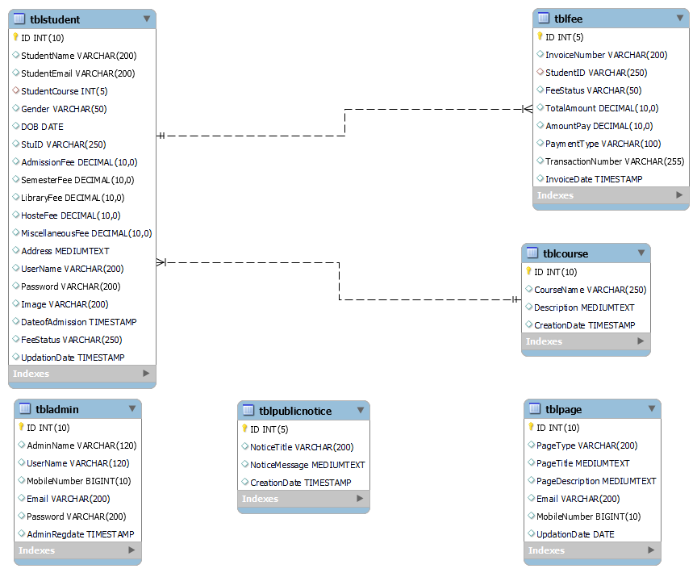

**ER Diagram:**

The Entity-Relationship (ER) model was originally proposed by Peter in 1976 [Chen76] as a way to unify the network and relational database views. Simply stated the ER model is a conceptual data model that views the real world as entities and relationships. A basic component of the model is the Entity-Relationship diagram which is used to visually represent data objects. Since Chen wrote his paper the model has been extended and today it is commonly used for database design for the database designer, the utility of the ER model is:

* It maps well to the relational model. The constructs used in the ER model can easily be transformed into relational tables.
* It is simple and easy to understand with a minimum of training. Therefore, the model can be used by the database designer to communicate the design to the end user.
* In addition, the model can be used as a design plan by the database developer to implement a data model in specific database management software.

**ER Notation**

There is no standard for representing data objects in ER diagrams. Each modeling methodology uses its own notation. The original notation used by Chen is widely used in academics texts and journals but rarely seen in either CASE tools or publications by non-academics. Today, there are a number of notations used; among the more common are Bachman, crow's foot, and IDEFIX.

All notational styles represent entities as rectangular boxes and relationships as lines connecting boxes. Each style uses a special set of symbols to represent the cardinality of a connection. The notation used in this document is from Martin. The symbols used for the basic ER constructs are:

* **Entities** are represented by labeled rectangles. The label is the name of the entity. Entity names should be singular nouns.
* **Relationships** are represented by a solid line connecting two entities. The name of the relationship is written above the line. Relationship names should be verbs
* **Attributes**, when included, are listed inside the entity rectangle. Attributes which are identifiers are underlined. Attribute names should be singular nouns.
* **Cardinality** of many is represented by a line ending in a crow's foot. If the crow's foot is omitted, the cardinality is one.

**Existence** is represented by placing a circle or a perpendicular bar on the line. Mandatory existence is shown by the bar (looks like a 1) next to the entity for an instance is required. Optional existence is shown by placing a circle next to the entity that is optional.

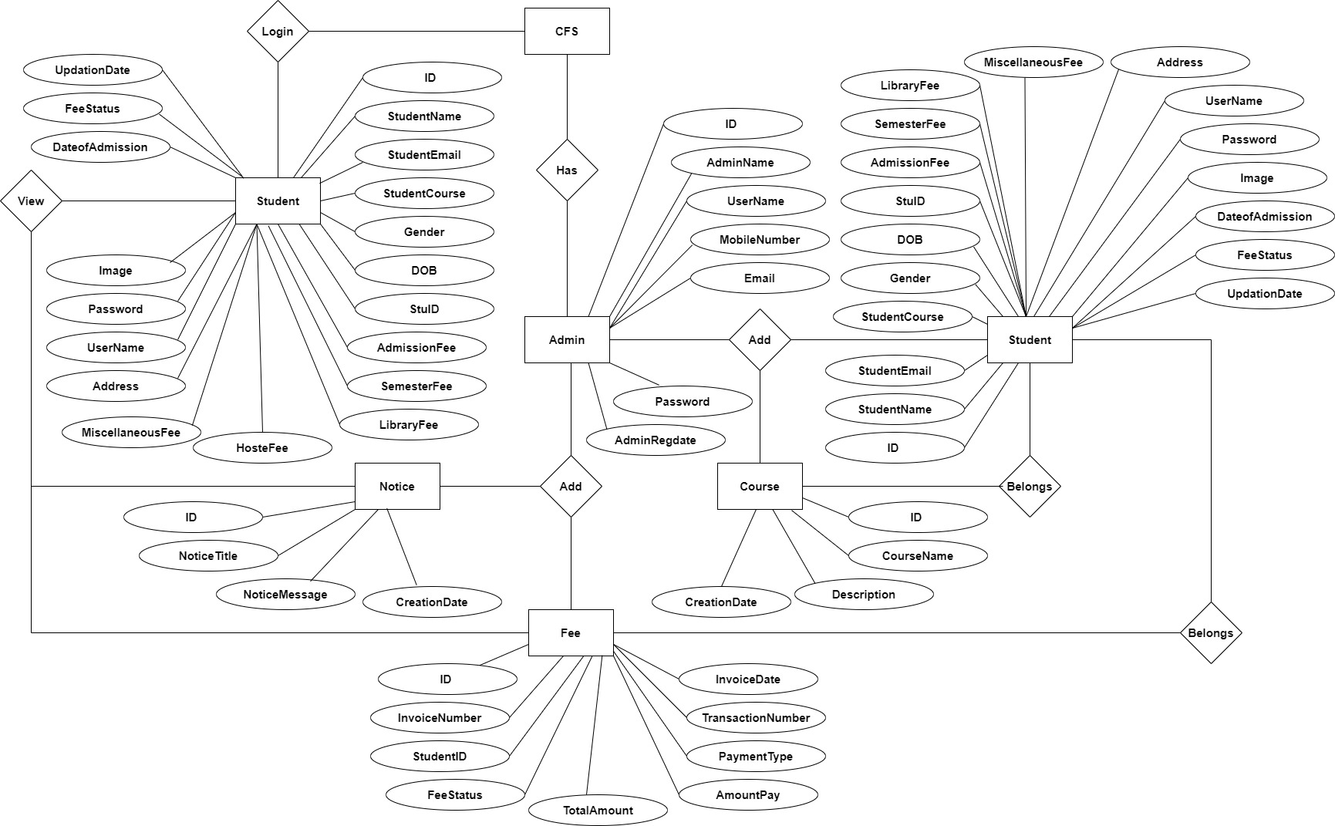

**Data Flow Diagram**

DFD graphically representing the functions, or processes, which capture, manipulate, store, and distribute data between a system and its environment and between components of a system. The visual representation makes it a good communication tool between User and System designer. Structure of DFD allows starting from a broad overview and expand it to a hierarchy of detailed diagrams. DFD has often been used due to the following reasons:

* Logical information flow of the system
* Determination of physical system construction requirements
* Simplicity of notation
* Establishment of manual and automated systems requirements

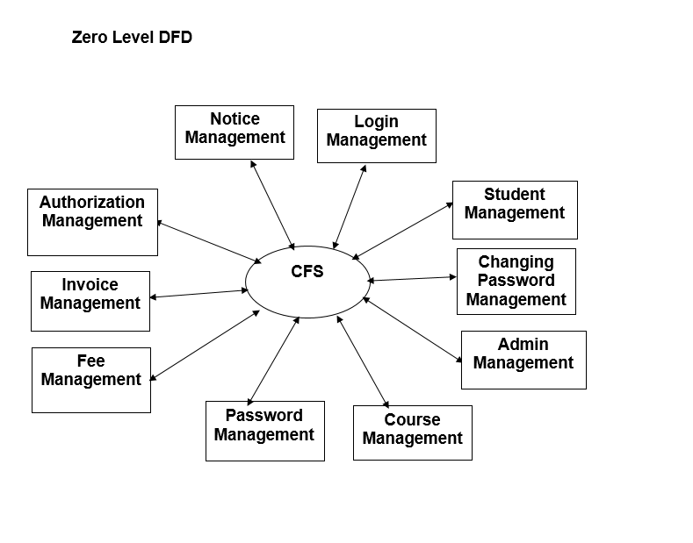

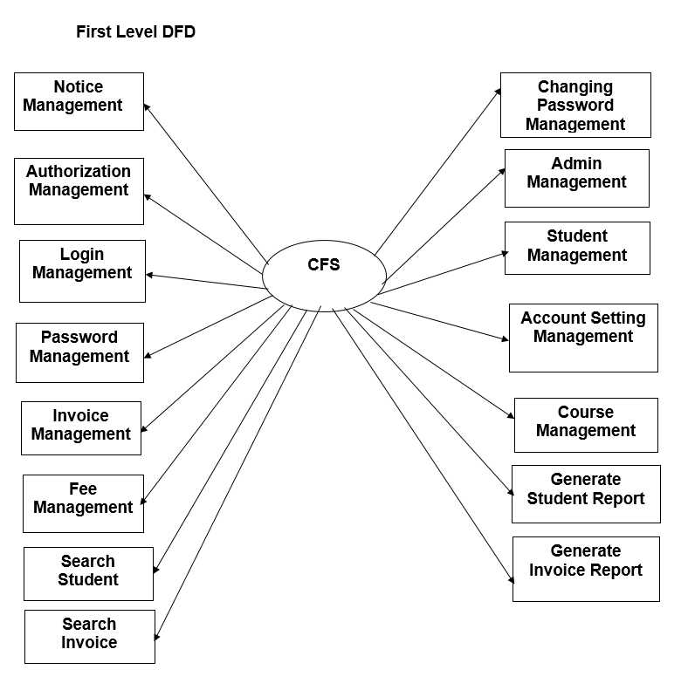

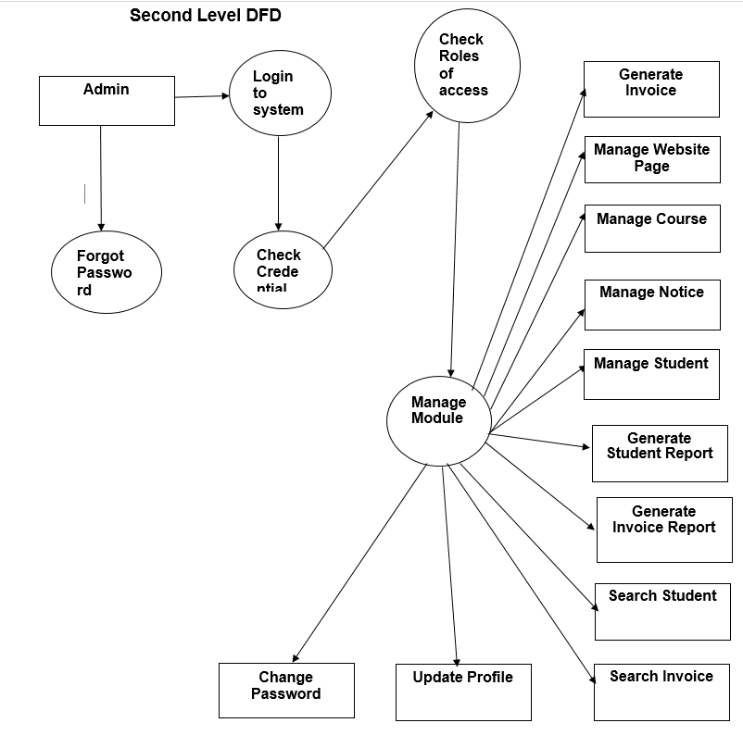

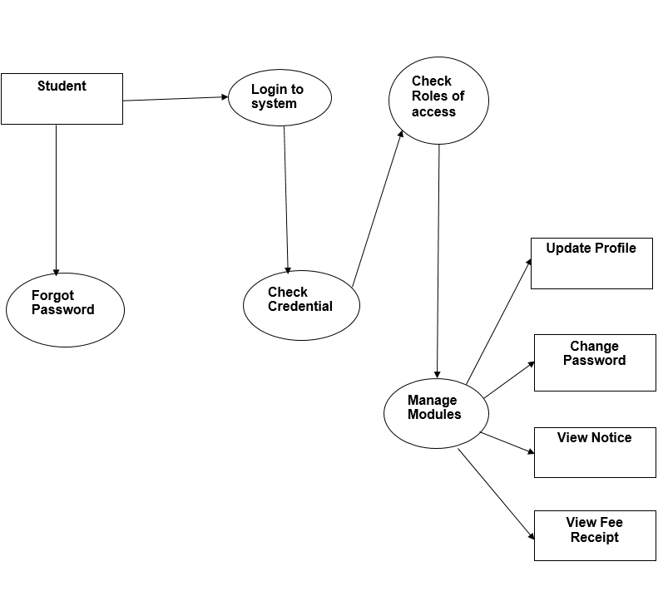

**MySQL Data Tables**

**Admin Table :**( Table name is admin)

This table store admin personal and login details.

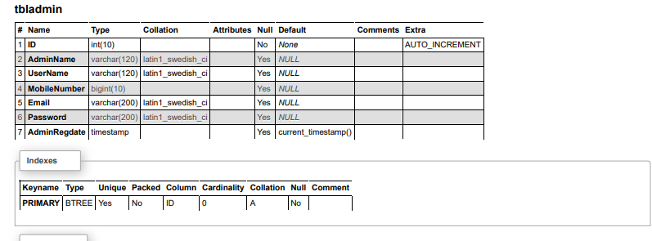

**Course Table:** (Table name is tblcourse)

This table store courses details which is add by college administrator.

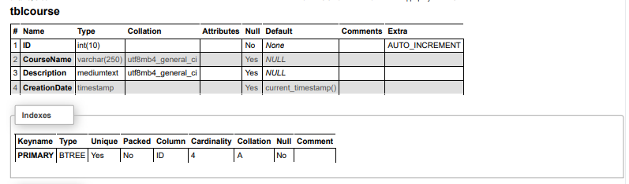

**Fee Table:** (Table name is tblfee)

This table store personal details of faculty.

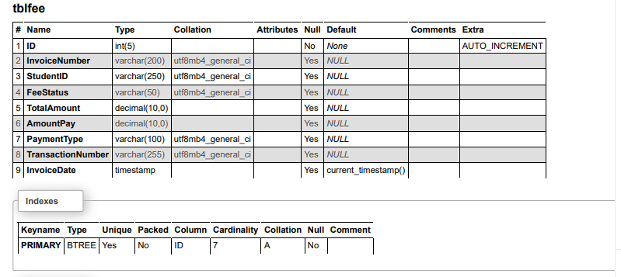

**Webpage Table:** (Table name is tblpage)

This table store the details of webpages.

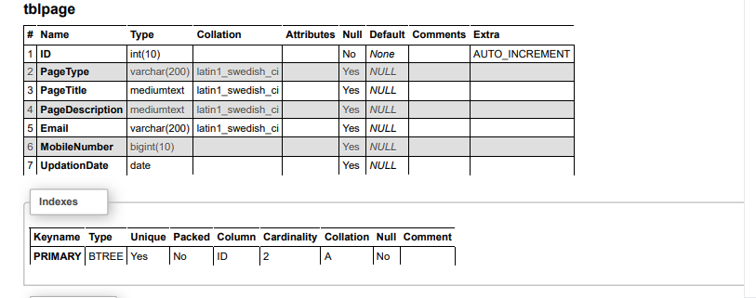

**Notice Table:** (Table name is tblpublicnotice)

This table store the details of notice which is announced by college administrator.

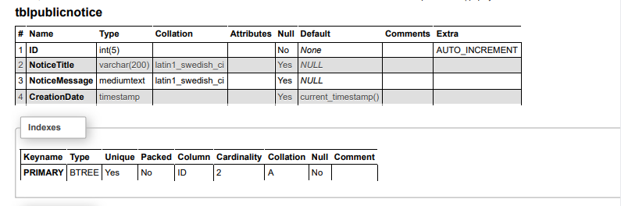

**Students Table:** (Table name is tblstudent)

This table store the details of students which is add by college administrator.

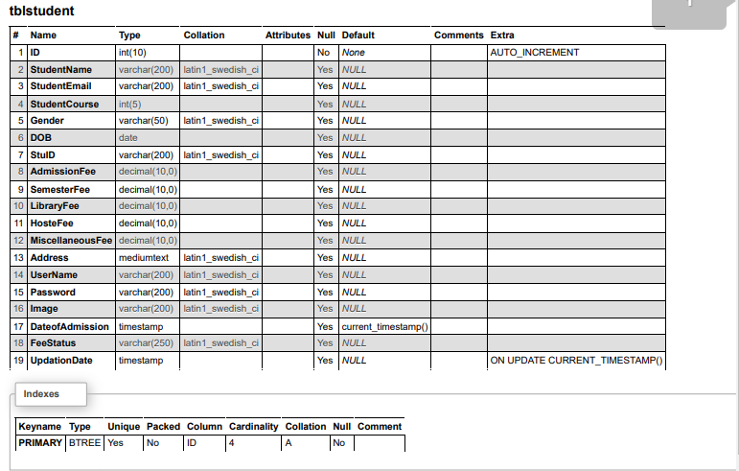

**Database Schema**

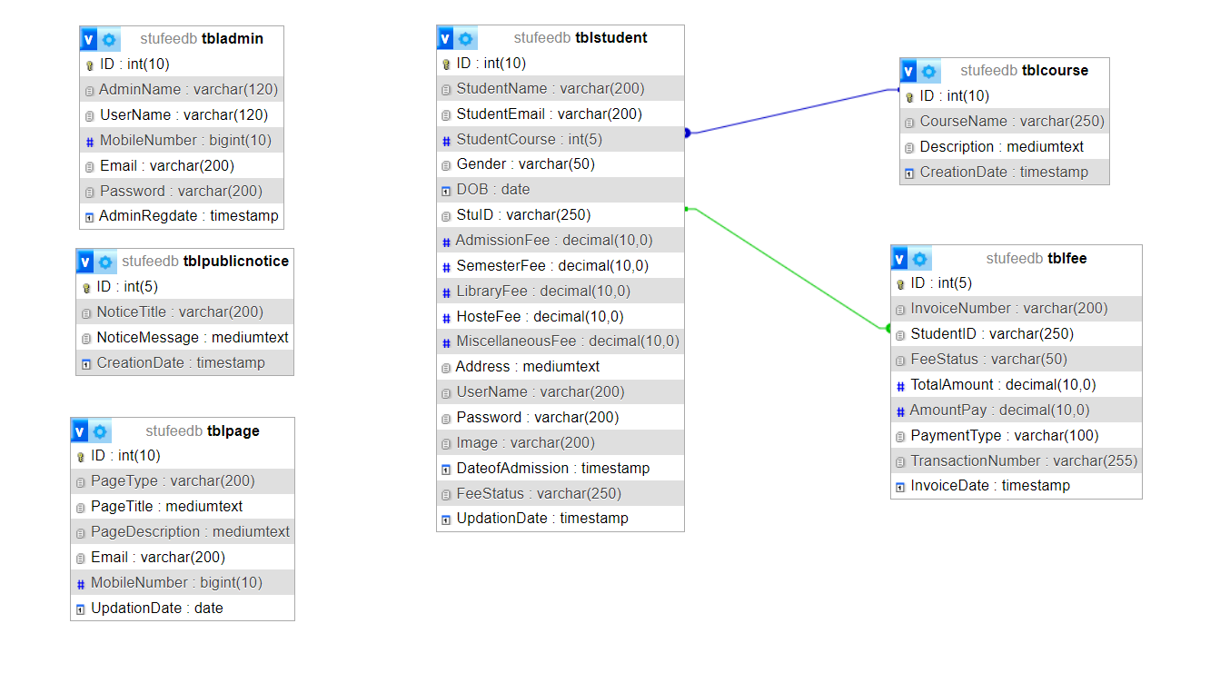

**Implementation and System Testing**

After all phase have been perfectly done, the system will be implemented to the server and the system can be used.

**System Testing**

The goal of the system testing process was to determine all faults in our project .The program was subjected to a set of test inputs and many explanations were made and based on these explanations it will be decided whether the program behaves as expected or not. Our Project went through two levels of testing

1. Unit testing

2. Integration testing

**UNIT TESTING**

Unit testing is commenced when a unit has been created and effectively reviewed .In order to test a single module we need to provide a complete environment i.e. besides the section we would require

* The procedures belonging to other units that the unit under test calls
* Non local data structures that module accesses
* A procedure to call the functions of the unit under test with appropriate parameters

**1. Test for the admin module**

* **Testing admin login form-**This form is used for log in of administrator of the system. In this form we enter the username and password if both are correct administration page will open otherwise if any of data is wrong it will get redirected back to the login page and again ask the details.
* **Report Generation:** admin can generate report from the main database.

**INTEGRATION TESTING**

In the Integration testing we test various combination of the project module by providing the input.

The primary objective is to test the module interfaces in order to confirm that no errors are occurring when one module invokes the other module.

**Evaluation**

**Project URL: http://localhost/stufeems**

**Home Page**



**Contact Us**

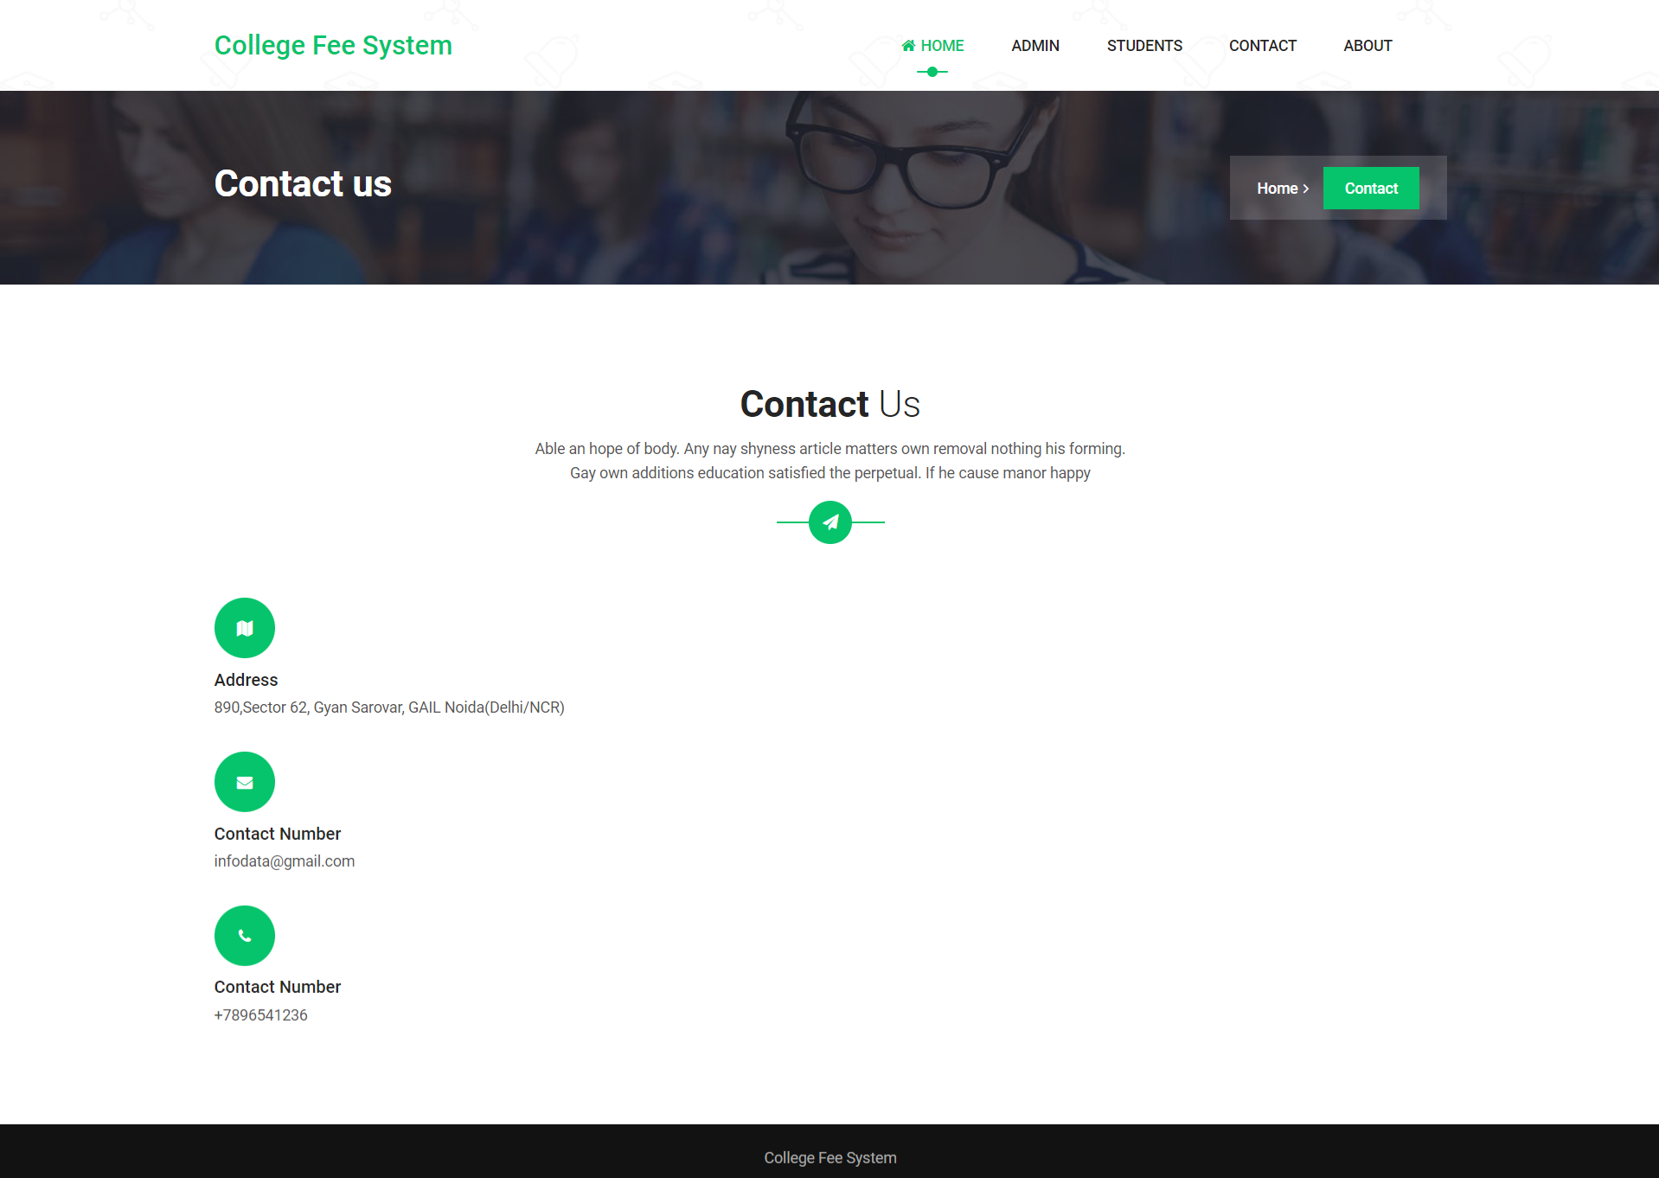

**About Us**

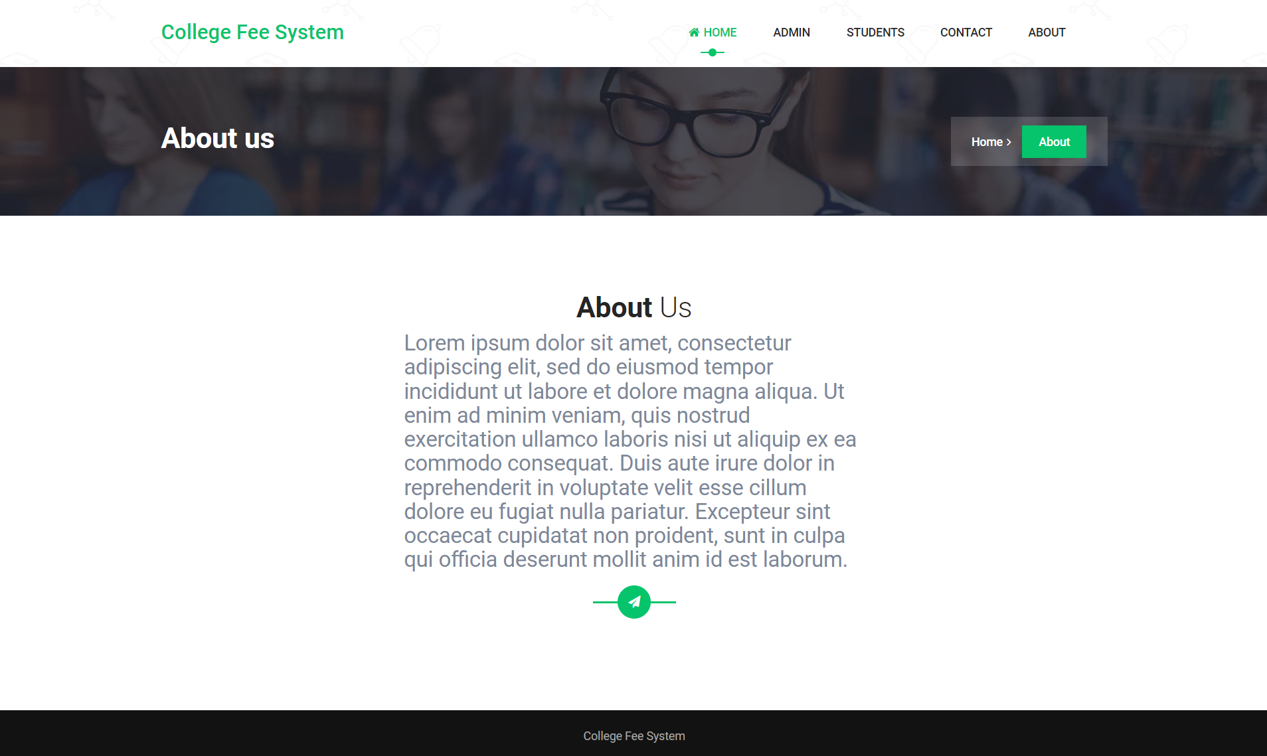

**Admin Panel**

**Login Page**

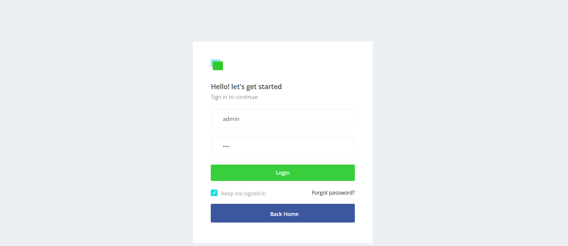

**Forgot Password**

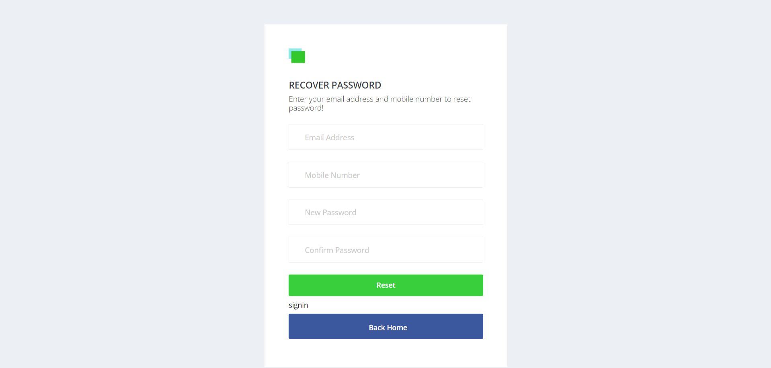

**Dashboard**

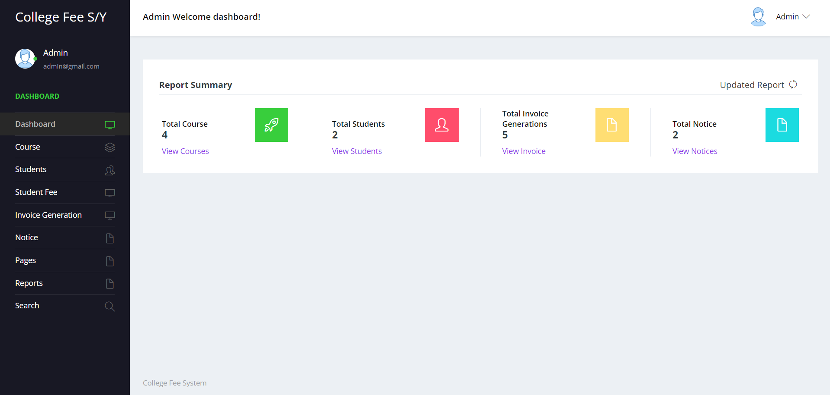

**Profile**

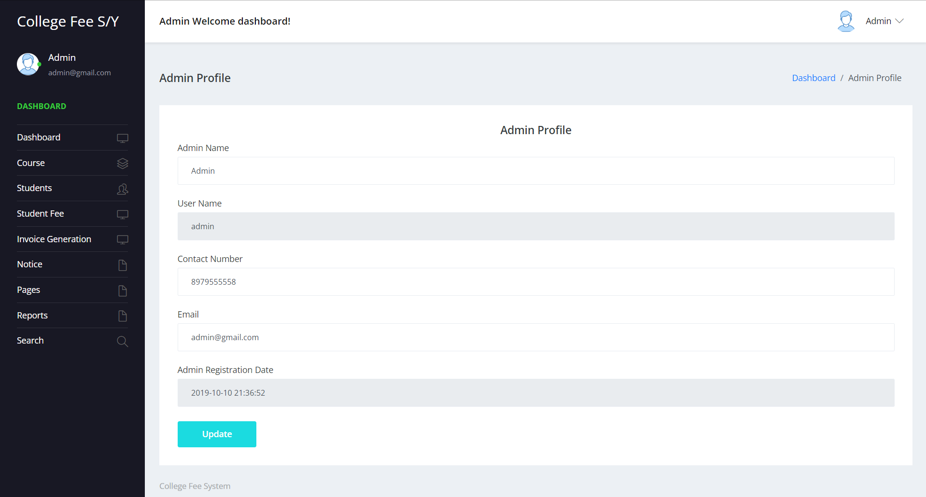

**Change Password**

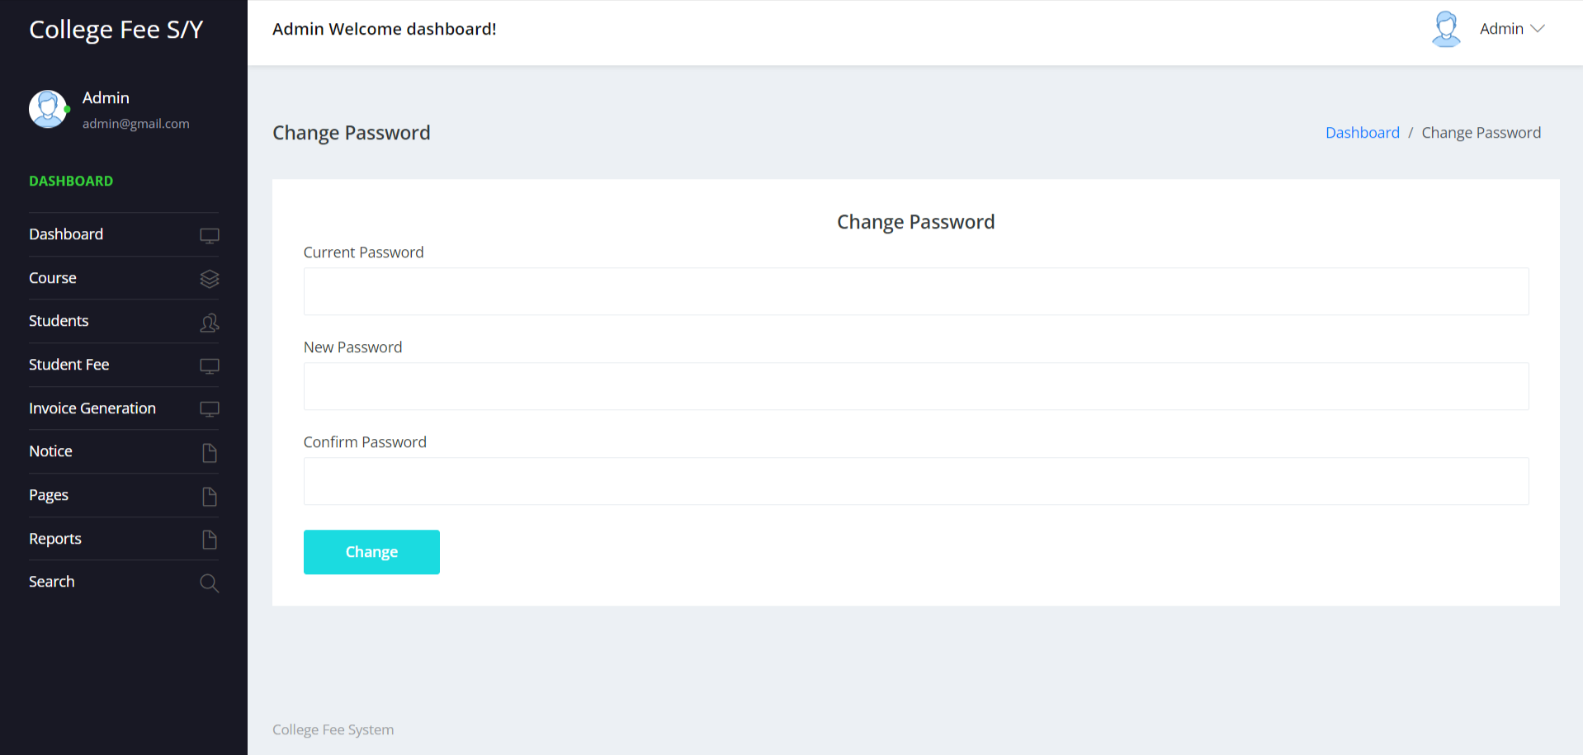

**Add Course**

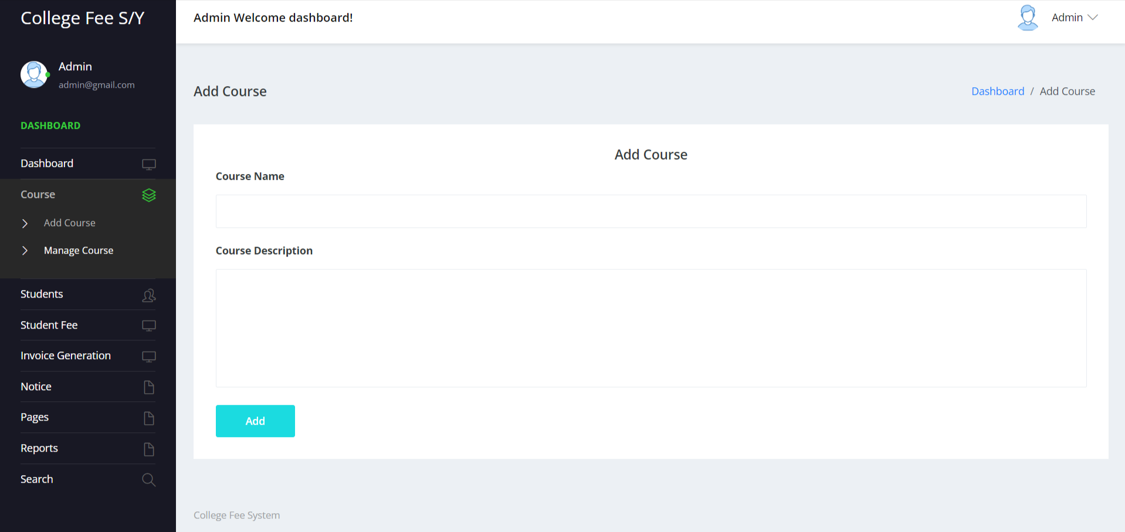

**Manage Course**

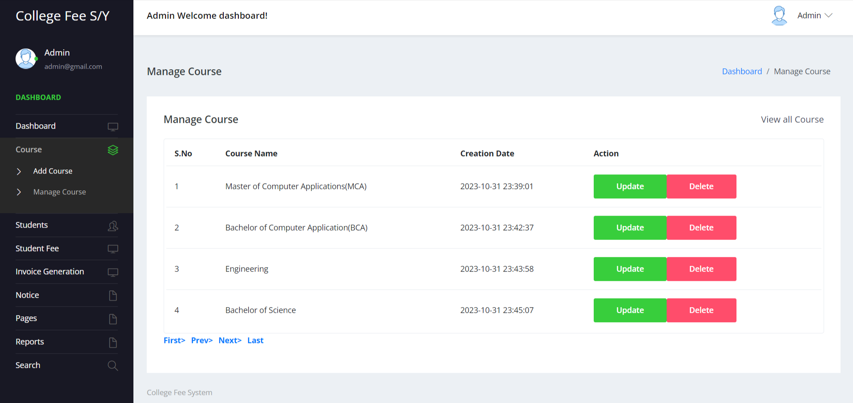

**Update Course**

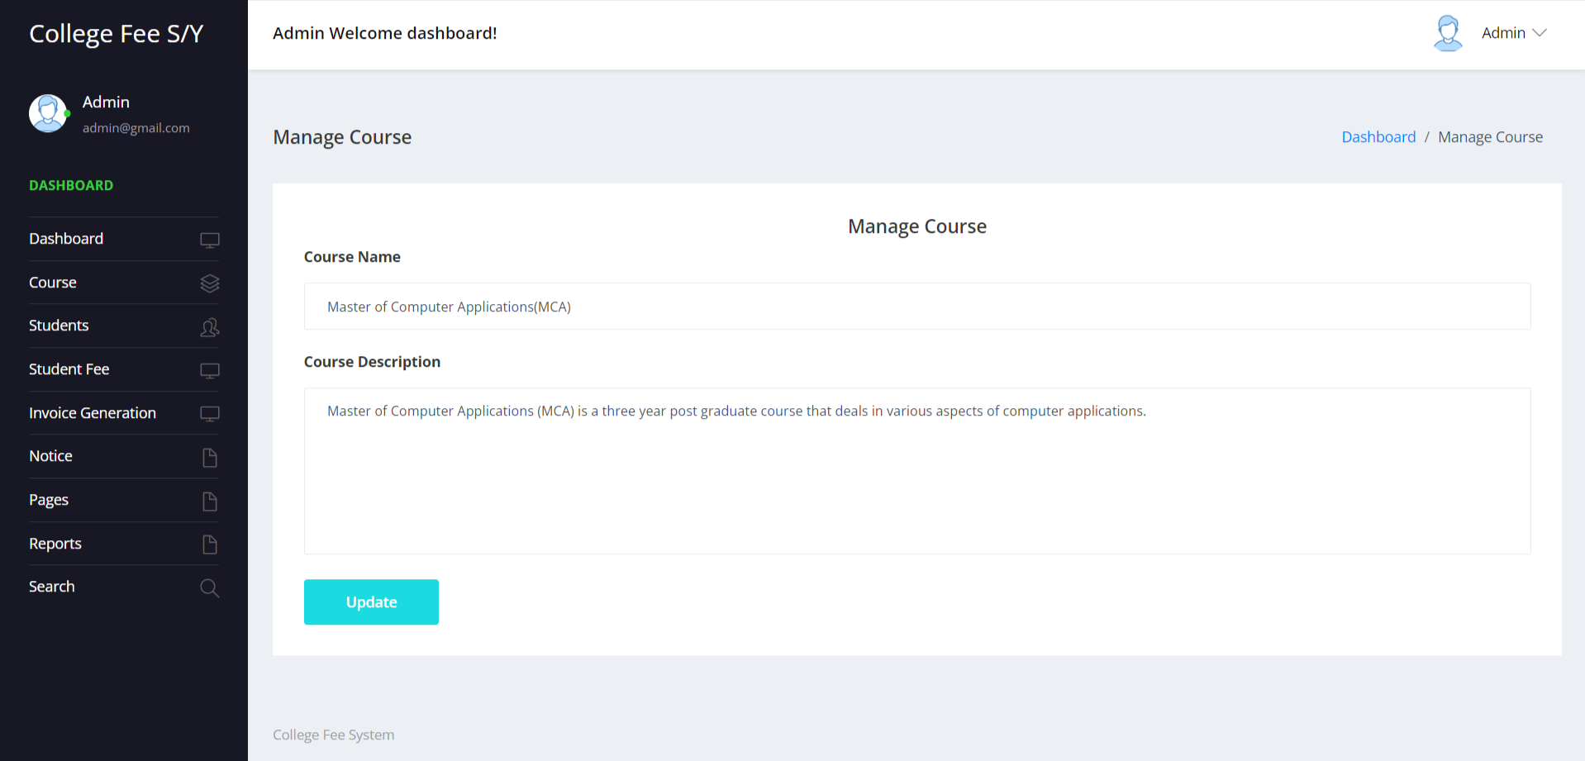

**Add Students**

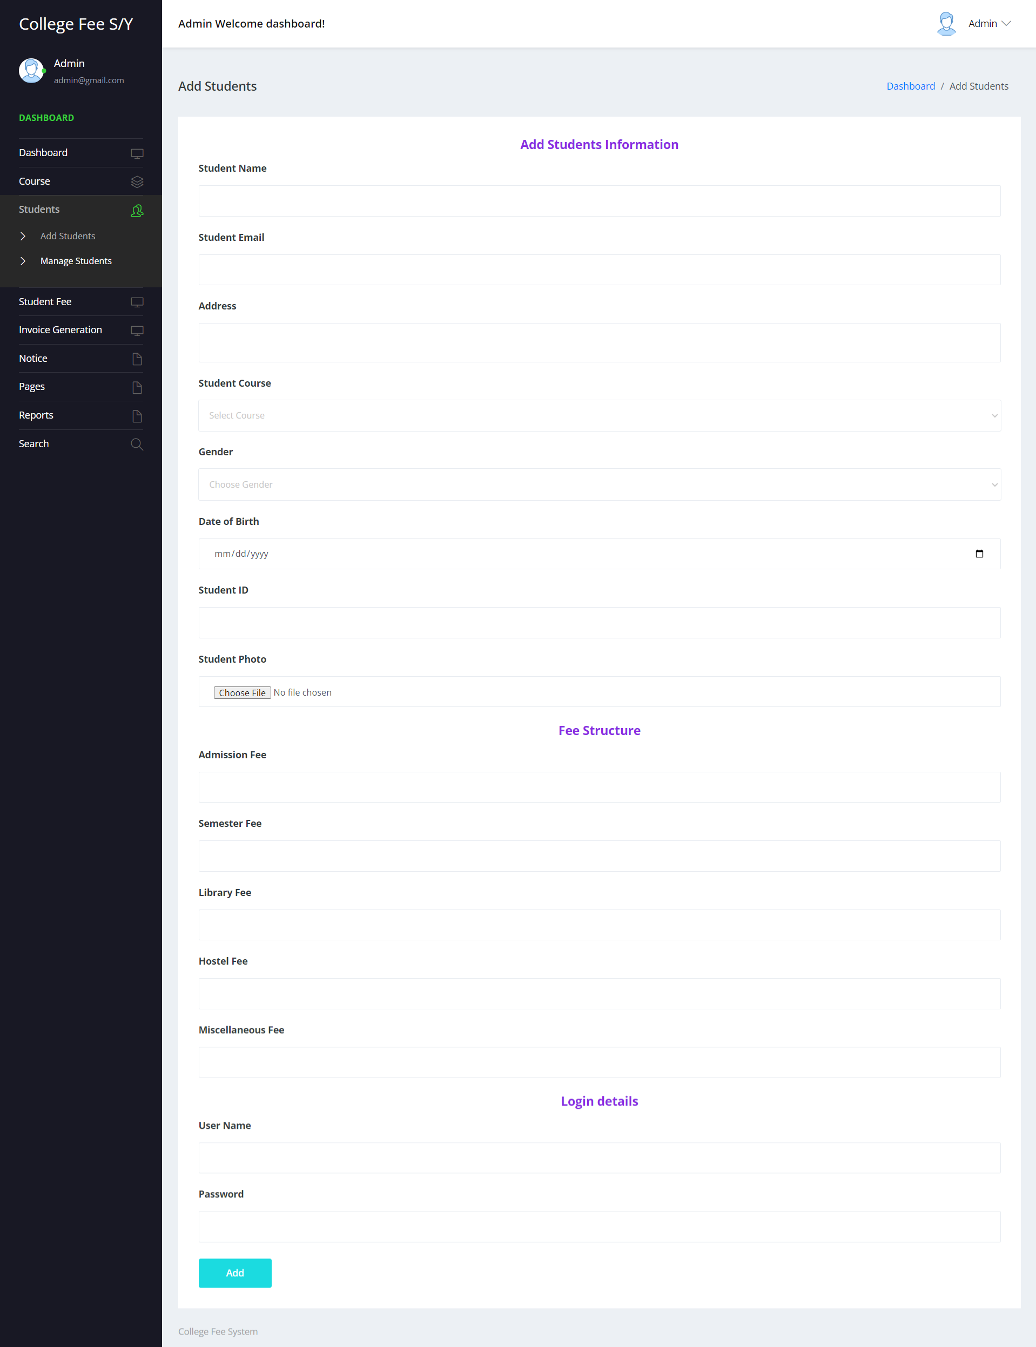

**Manage Students**

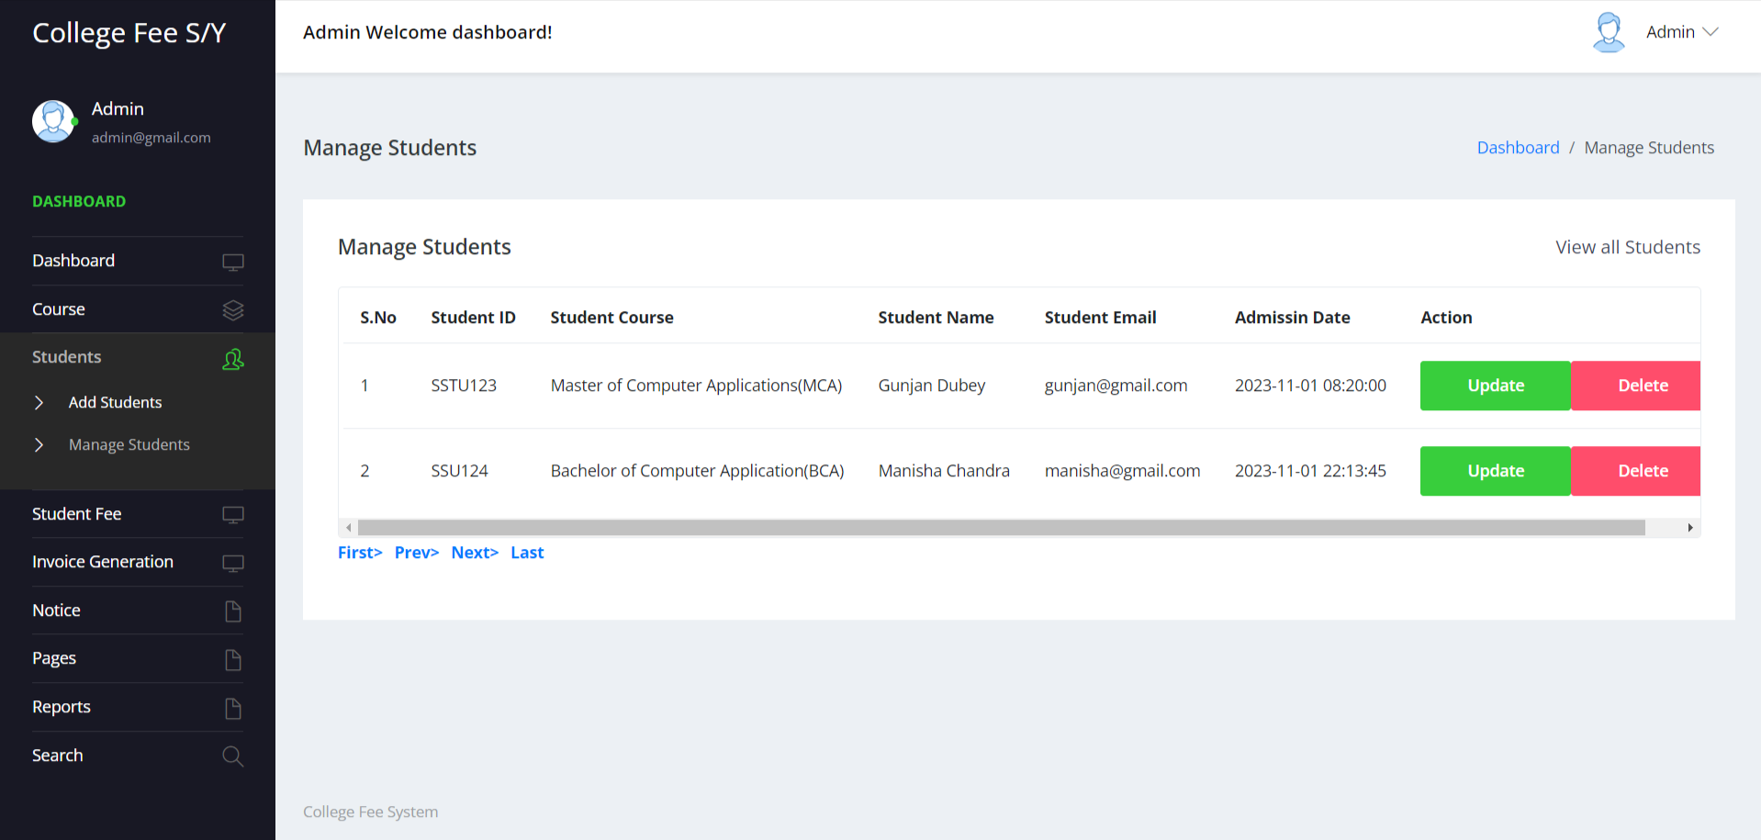

**Update Students**

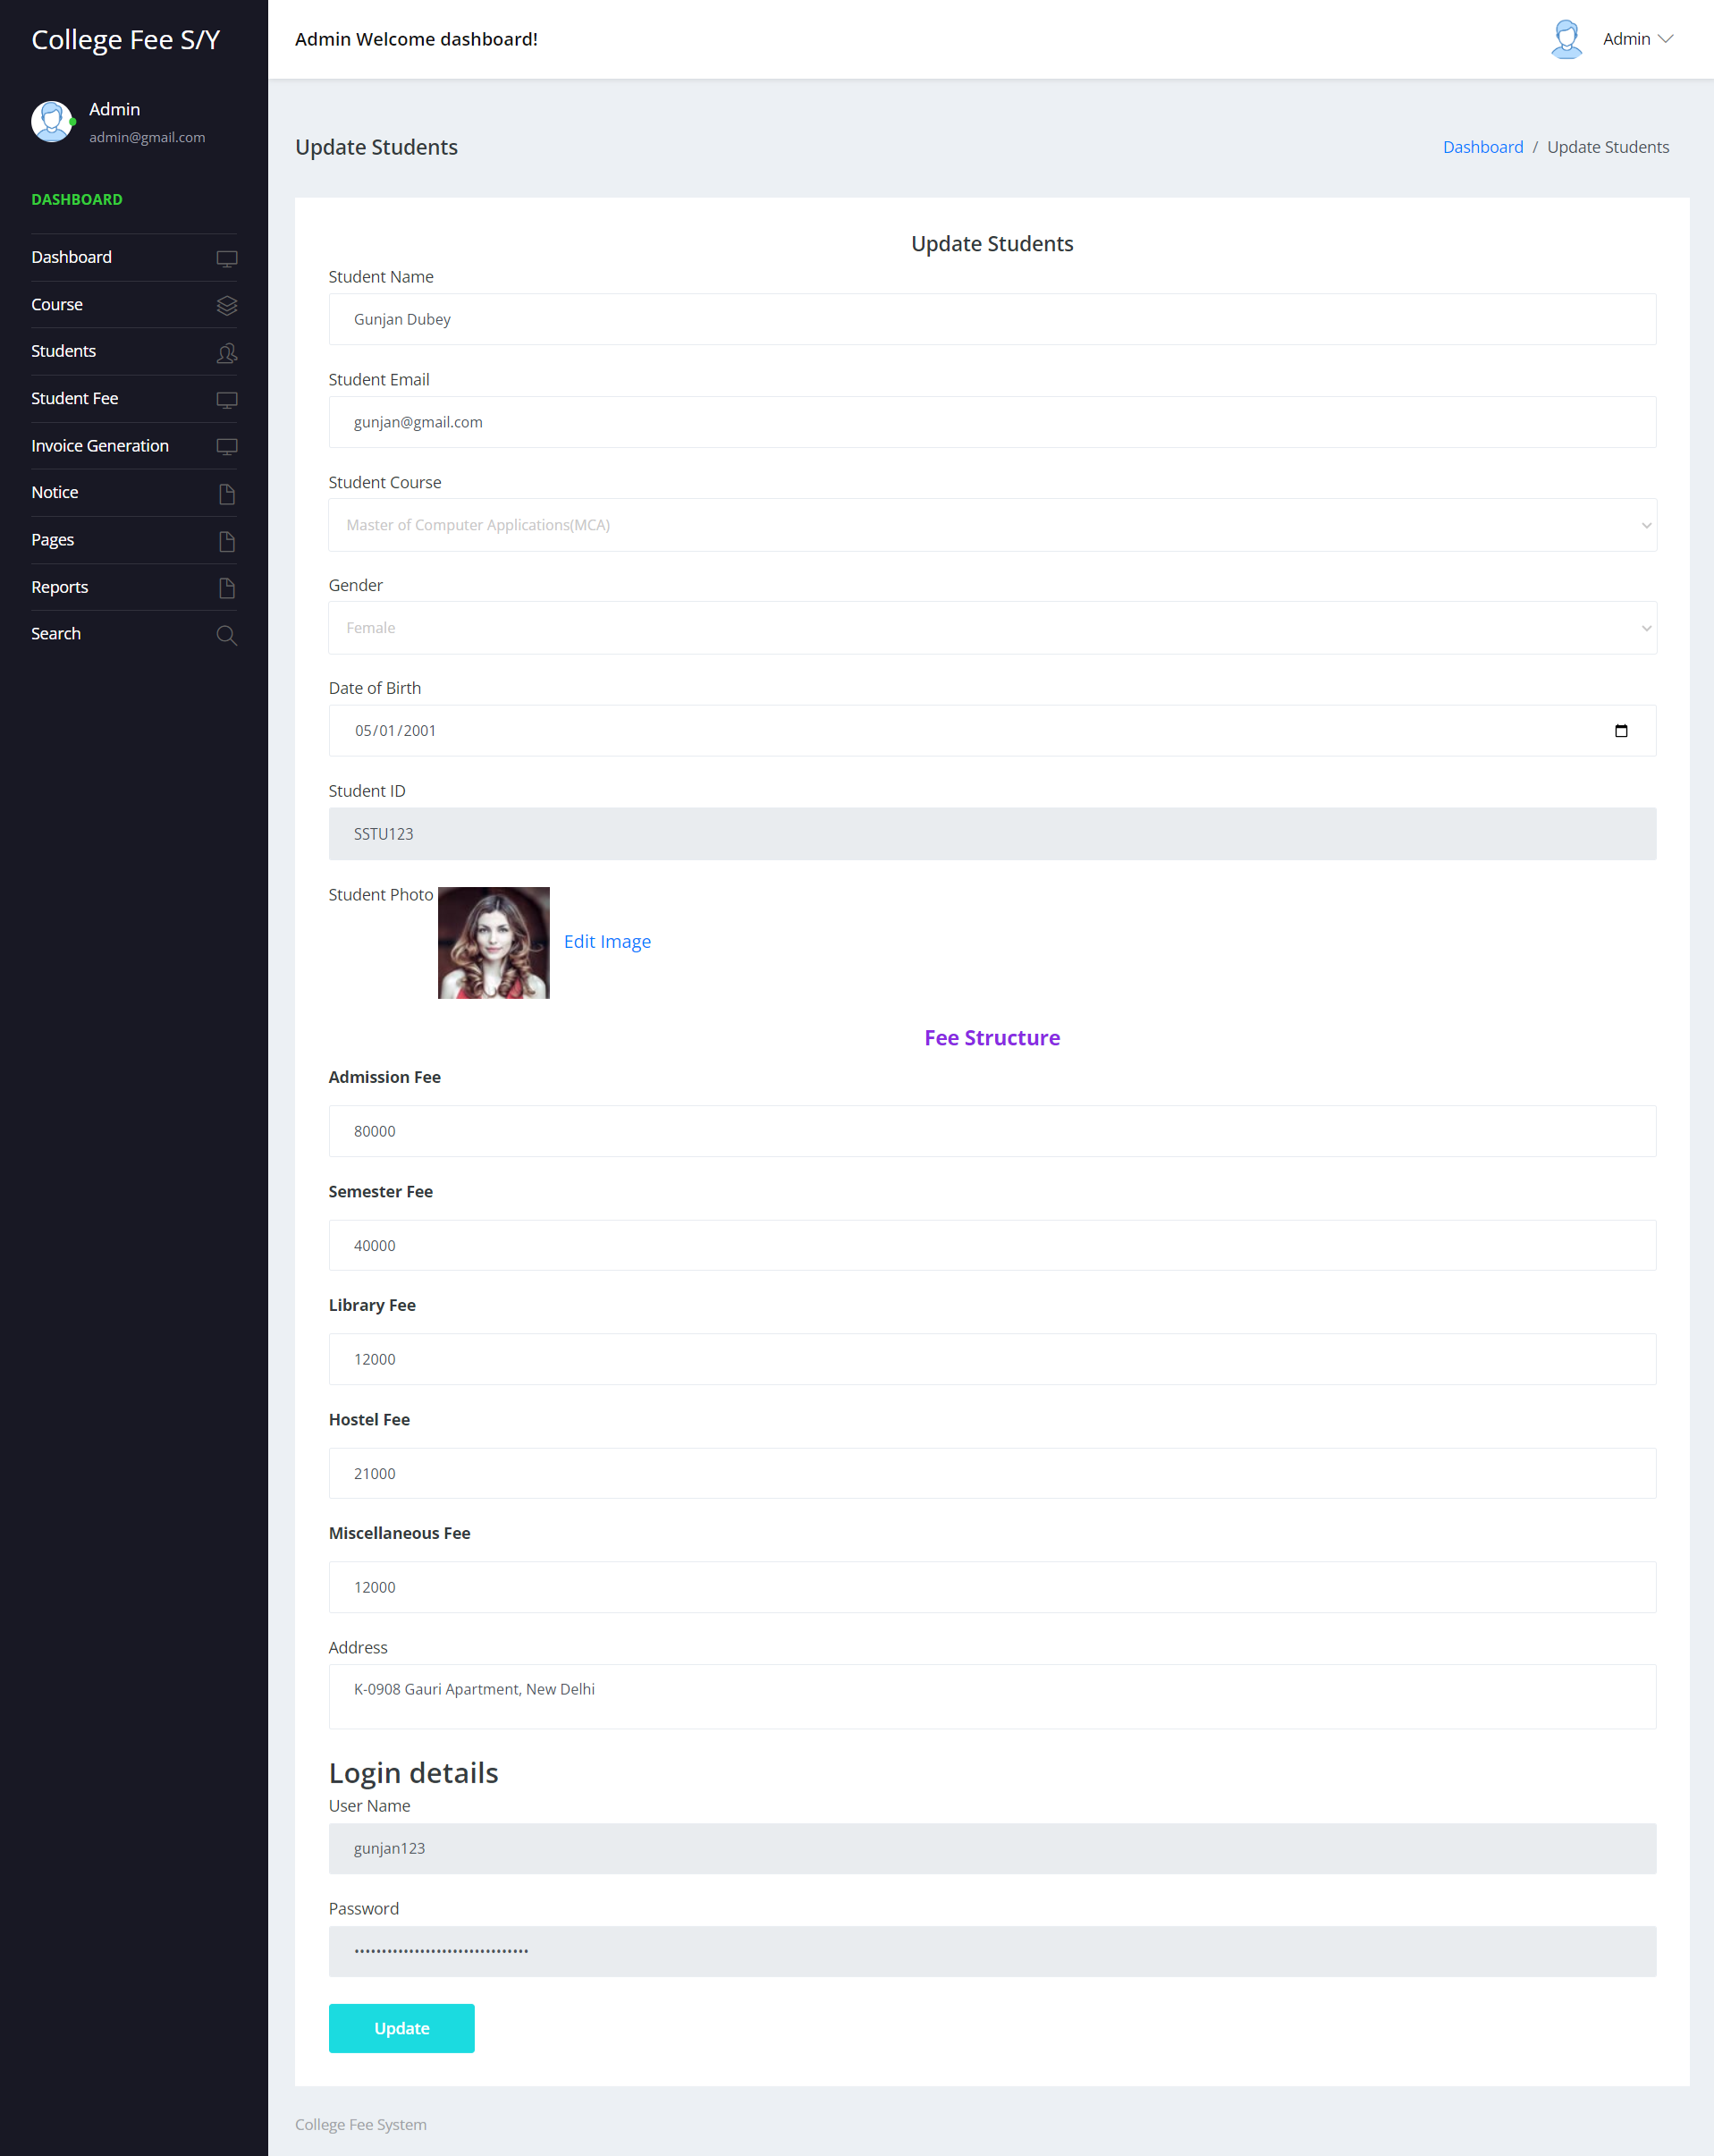

**Payment Details**

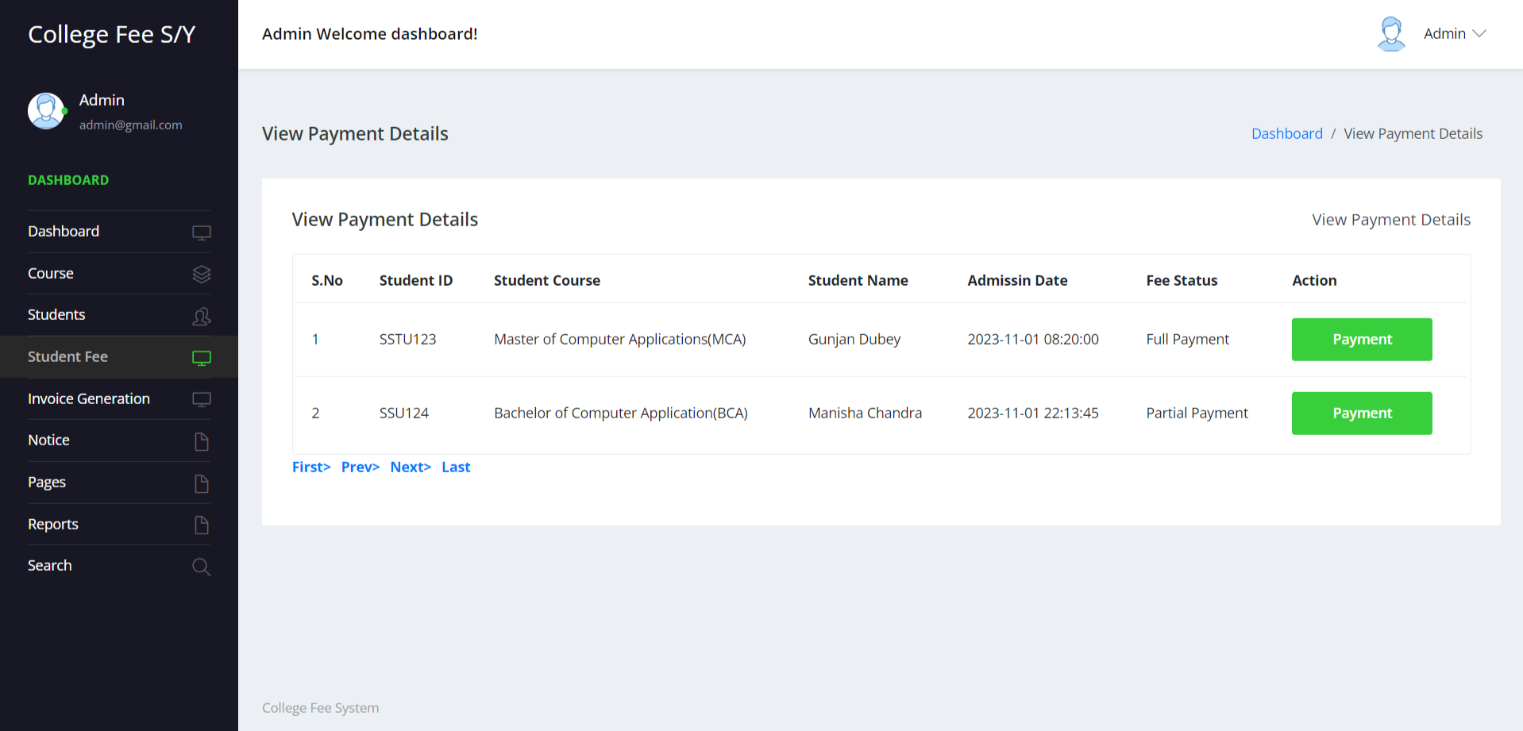

**View Payment Details**

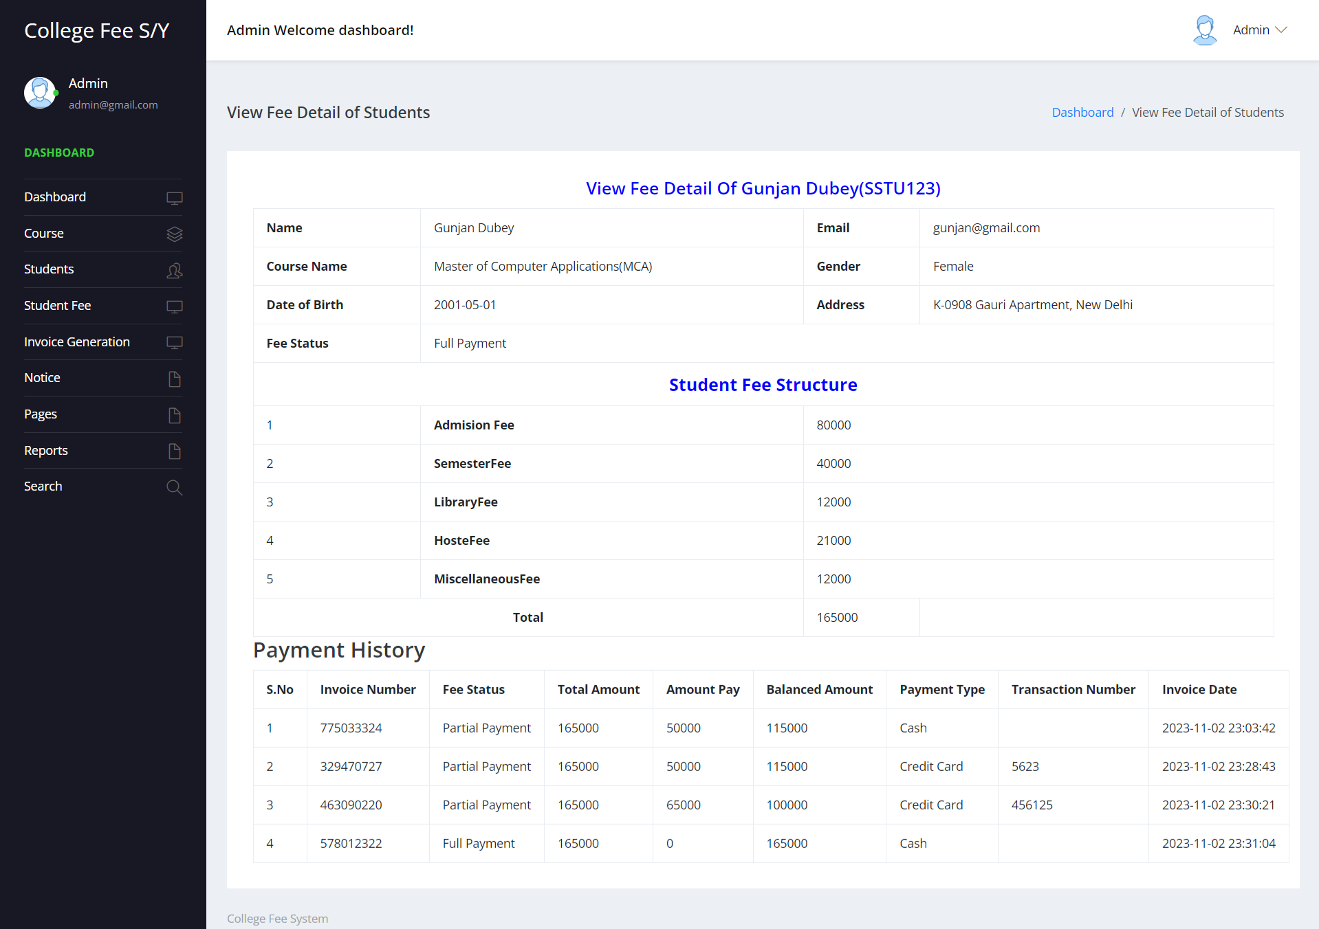

**Invoice Details**

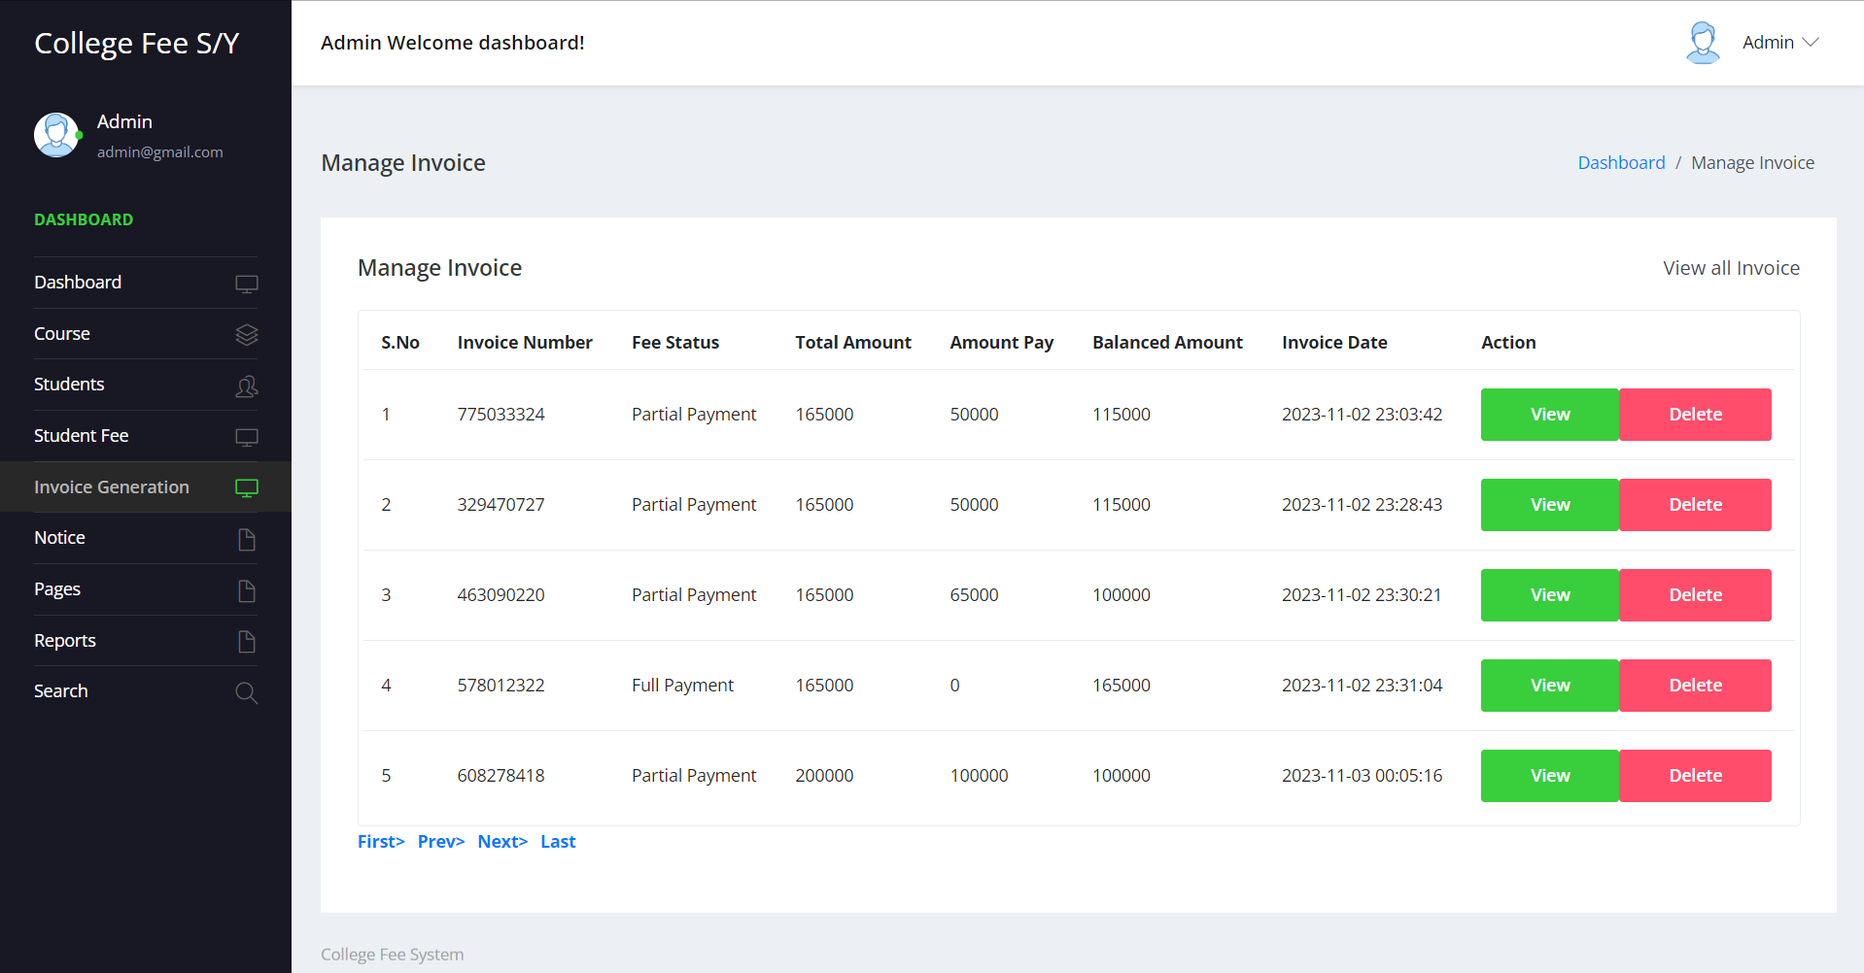

**Print Invoice Details**

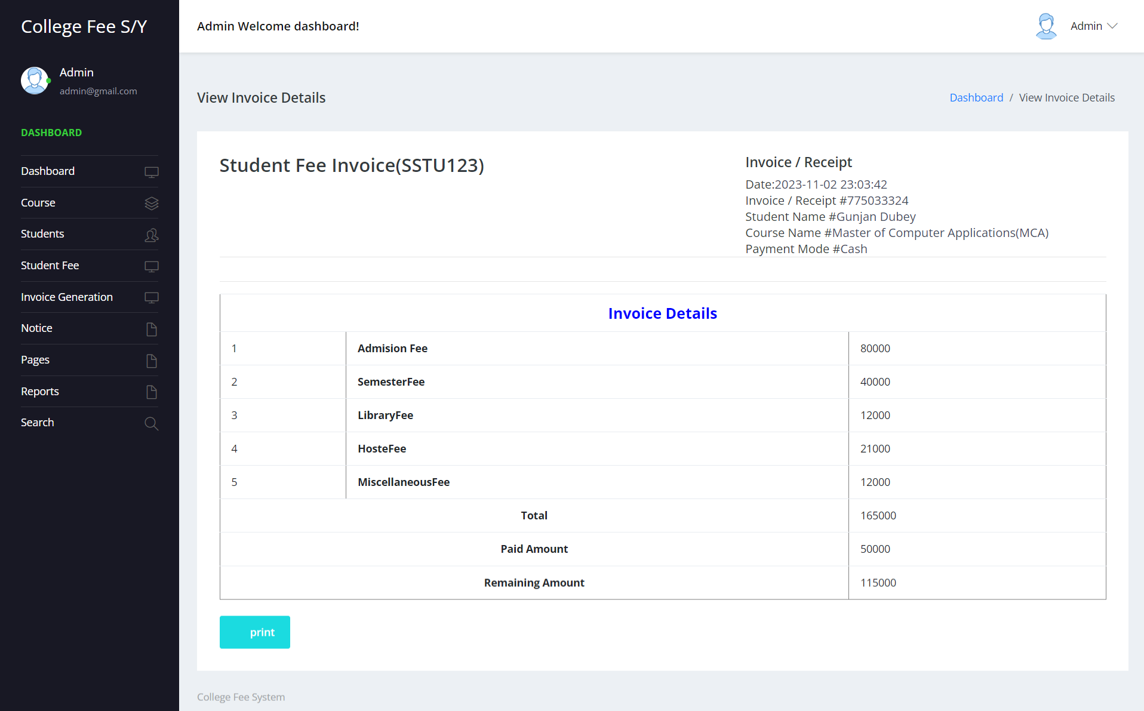

**Add Notice**

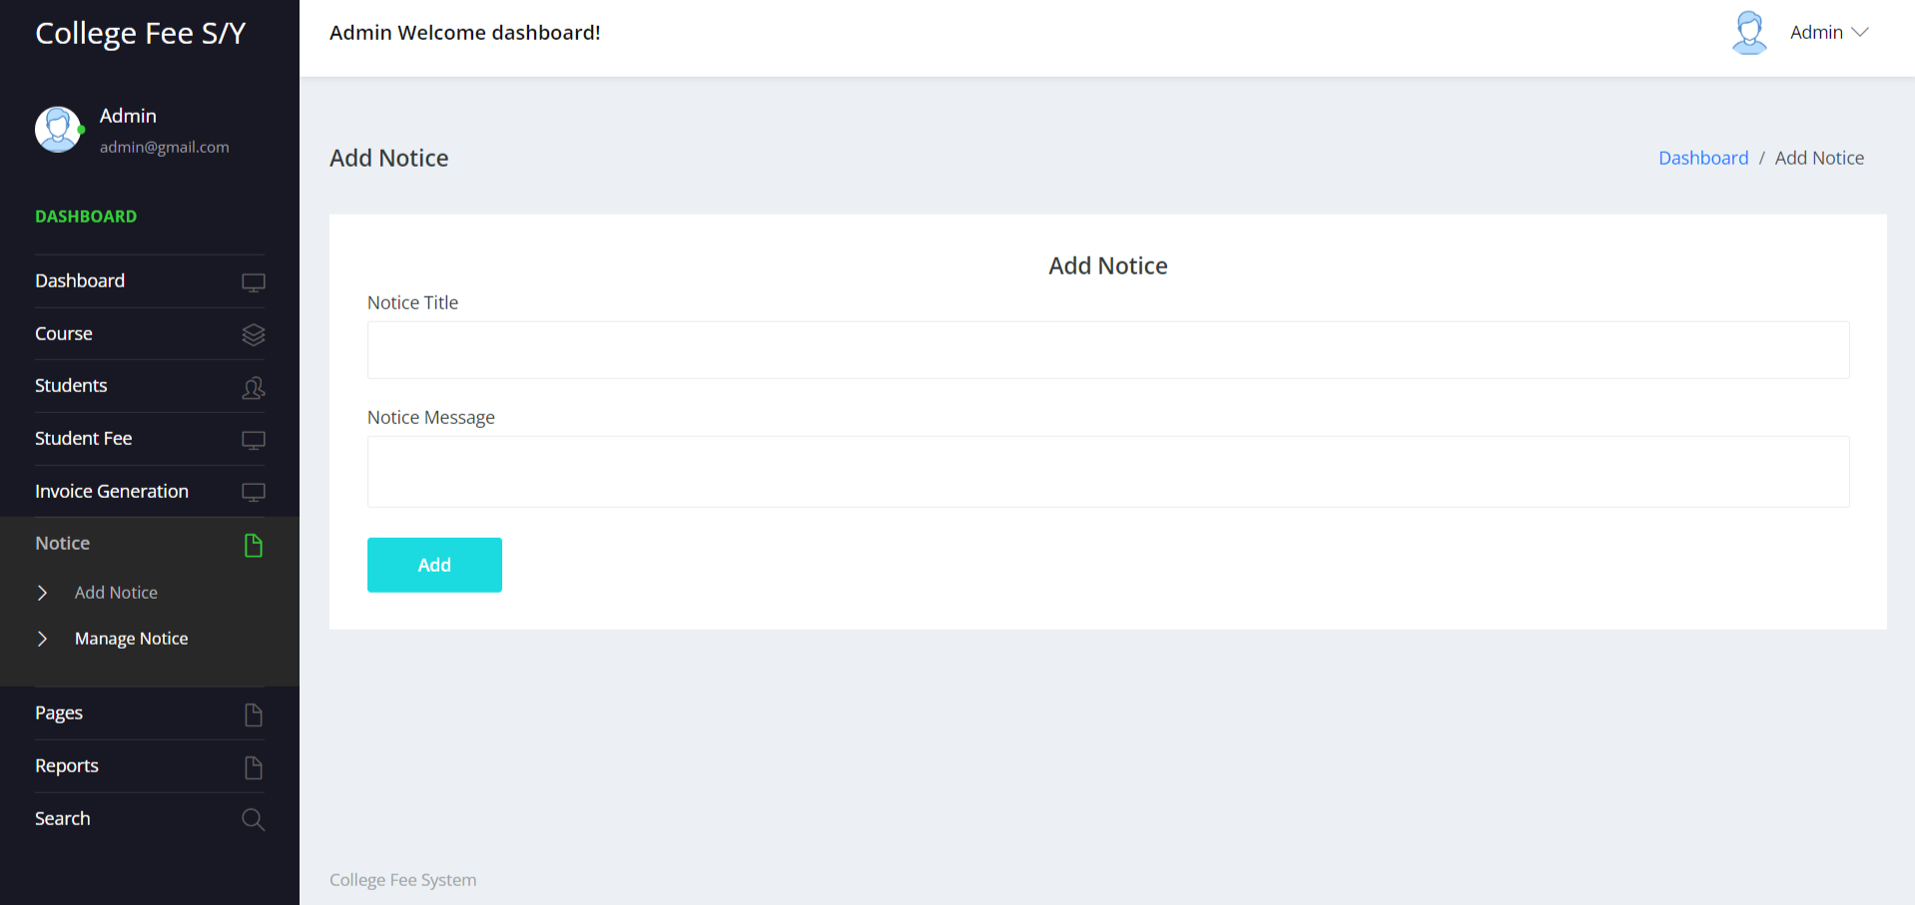

**Manage Notice**

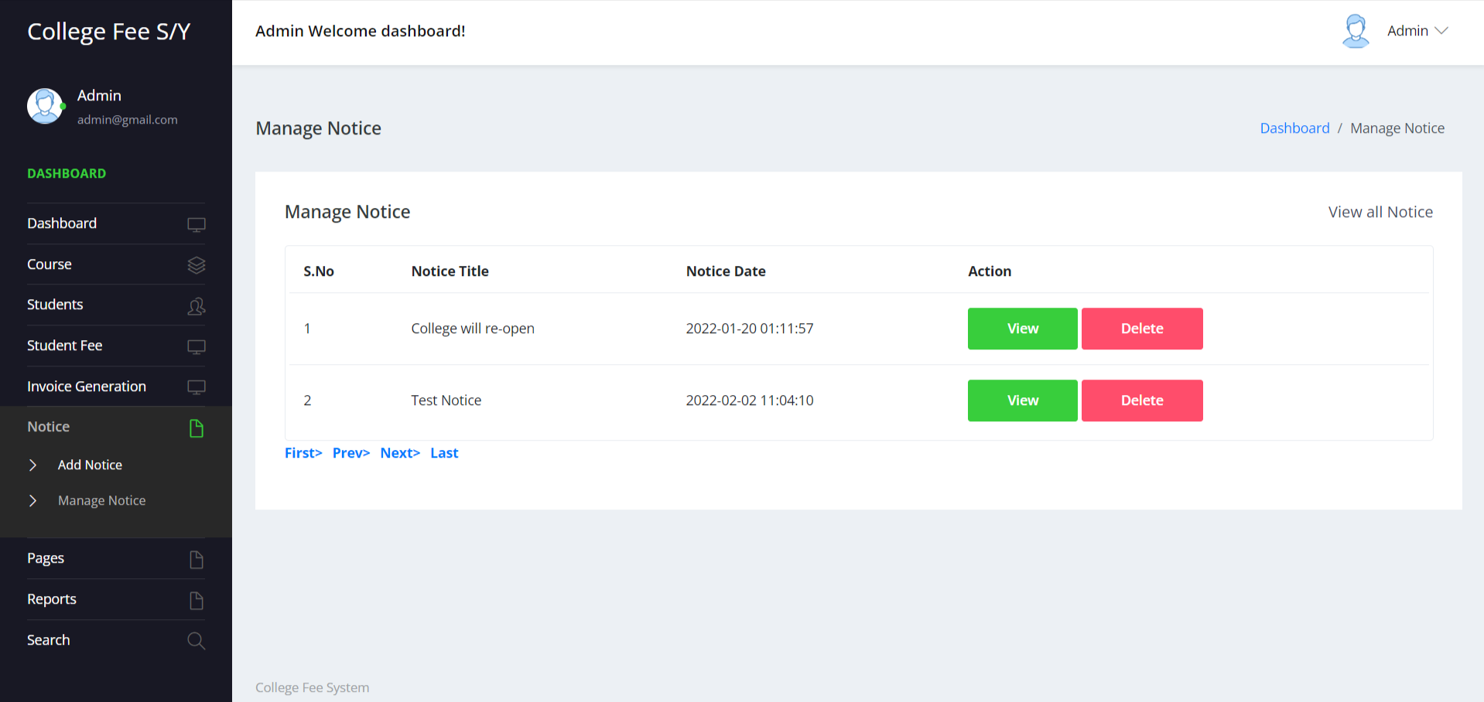

**View Notice**

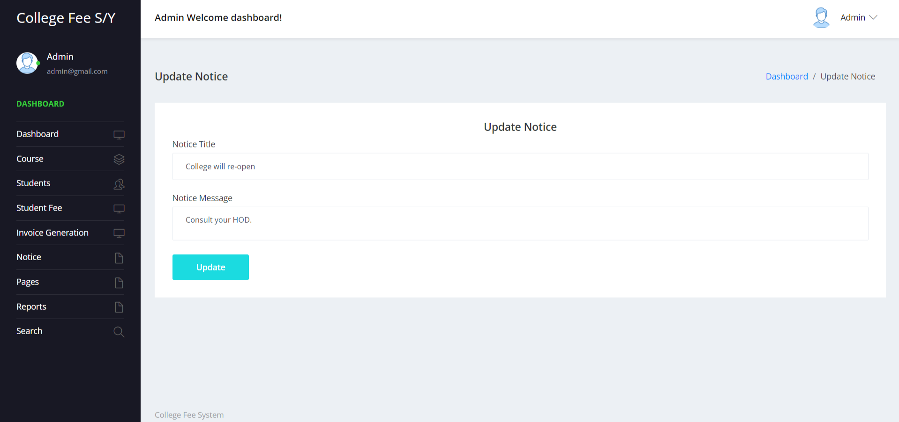

**About Us**

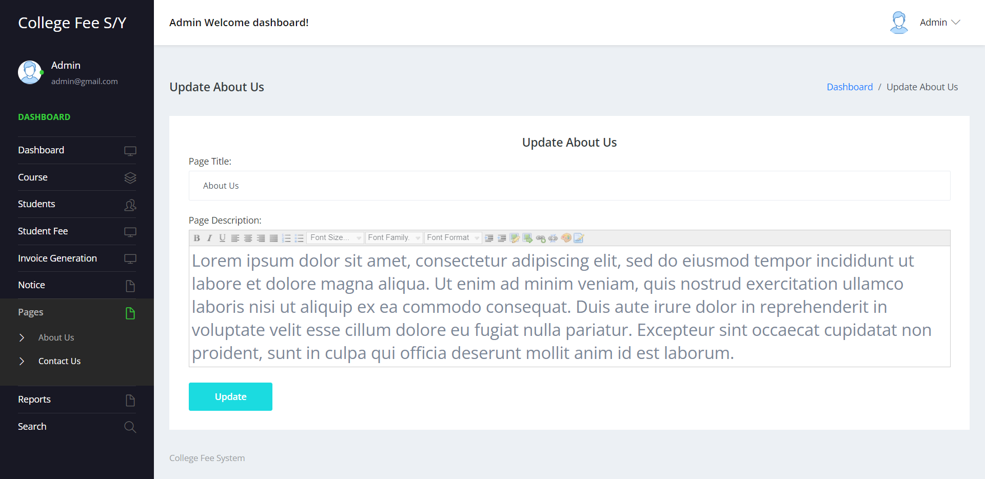

**Contact Us**

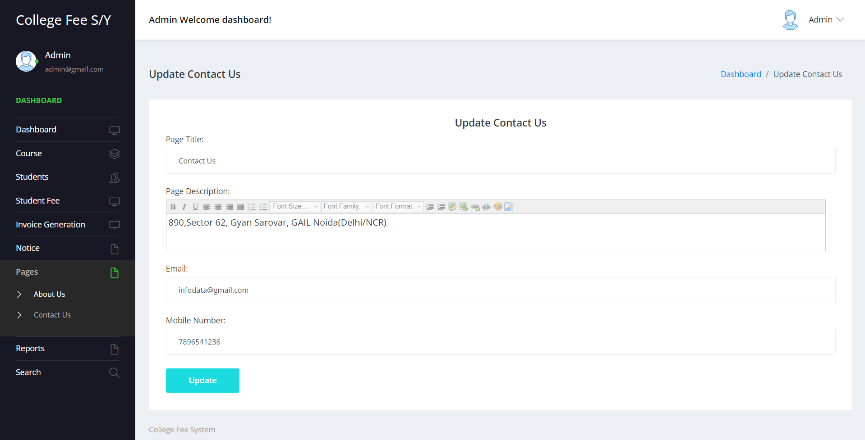

**Between Date Student Report**

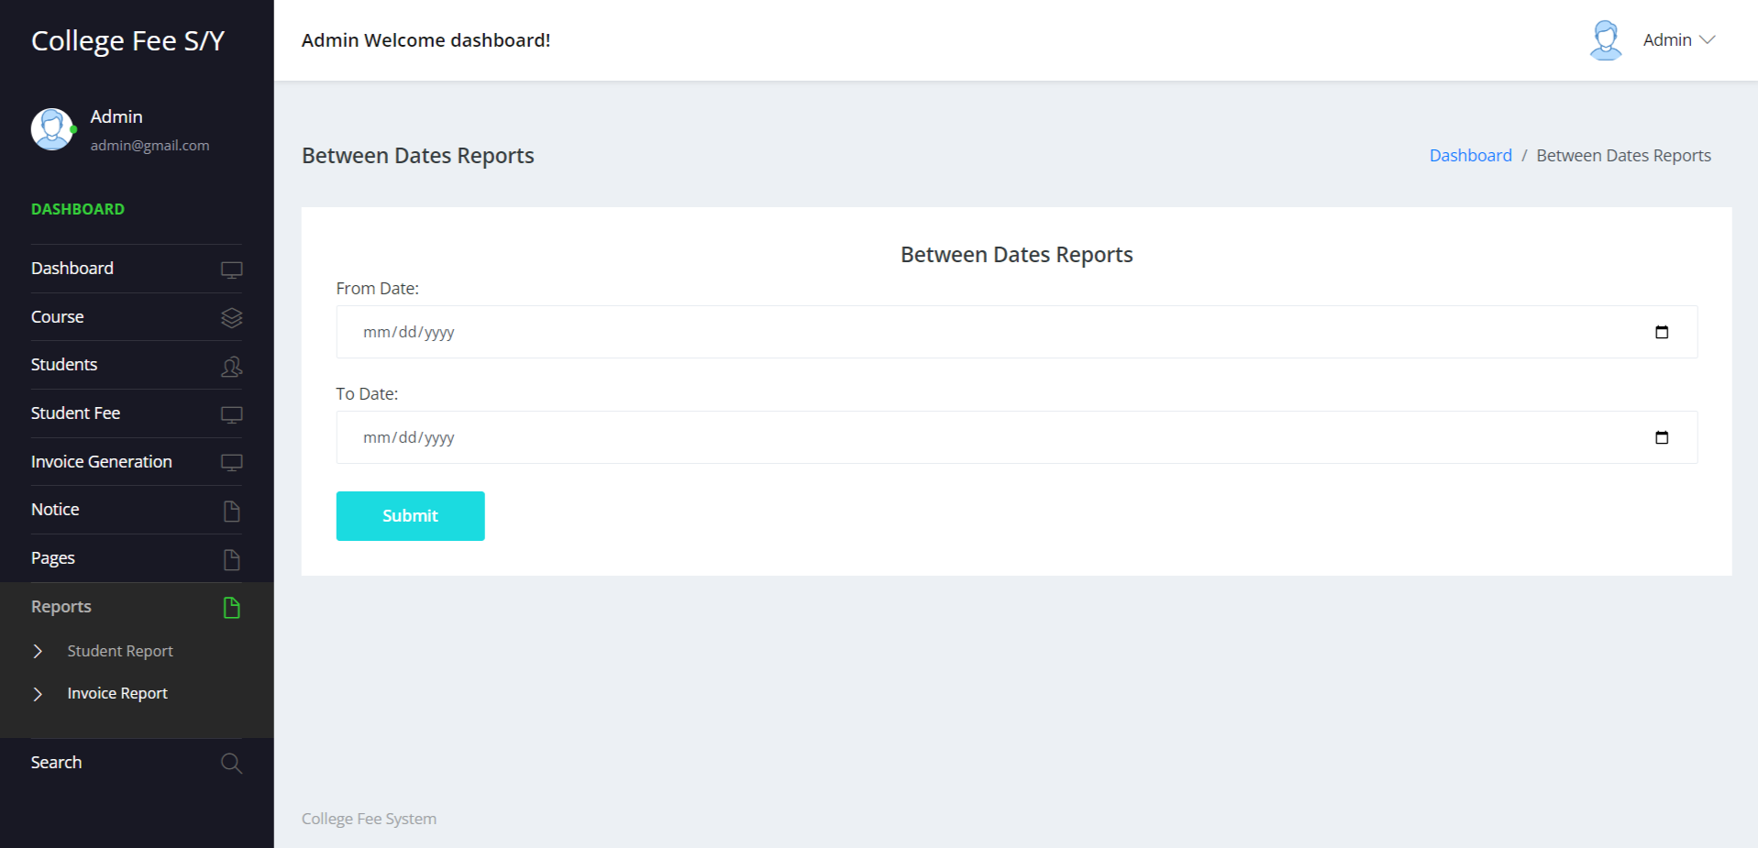

**View Details of Between Date Student Report**

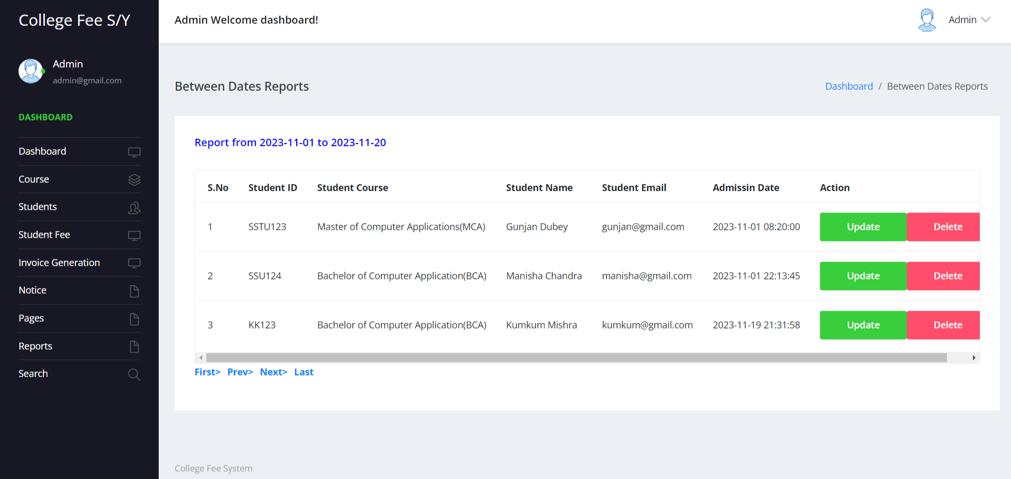

**Between Dates Invoice Report**

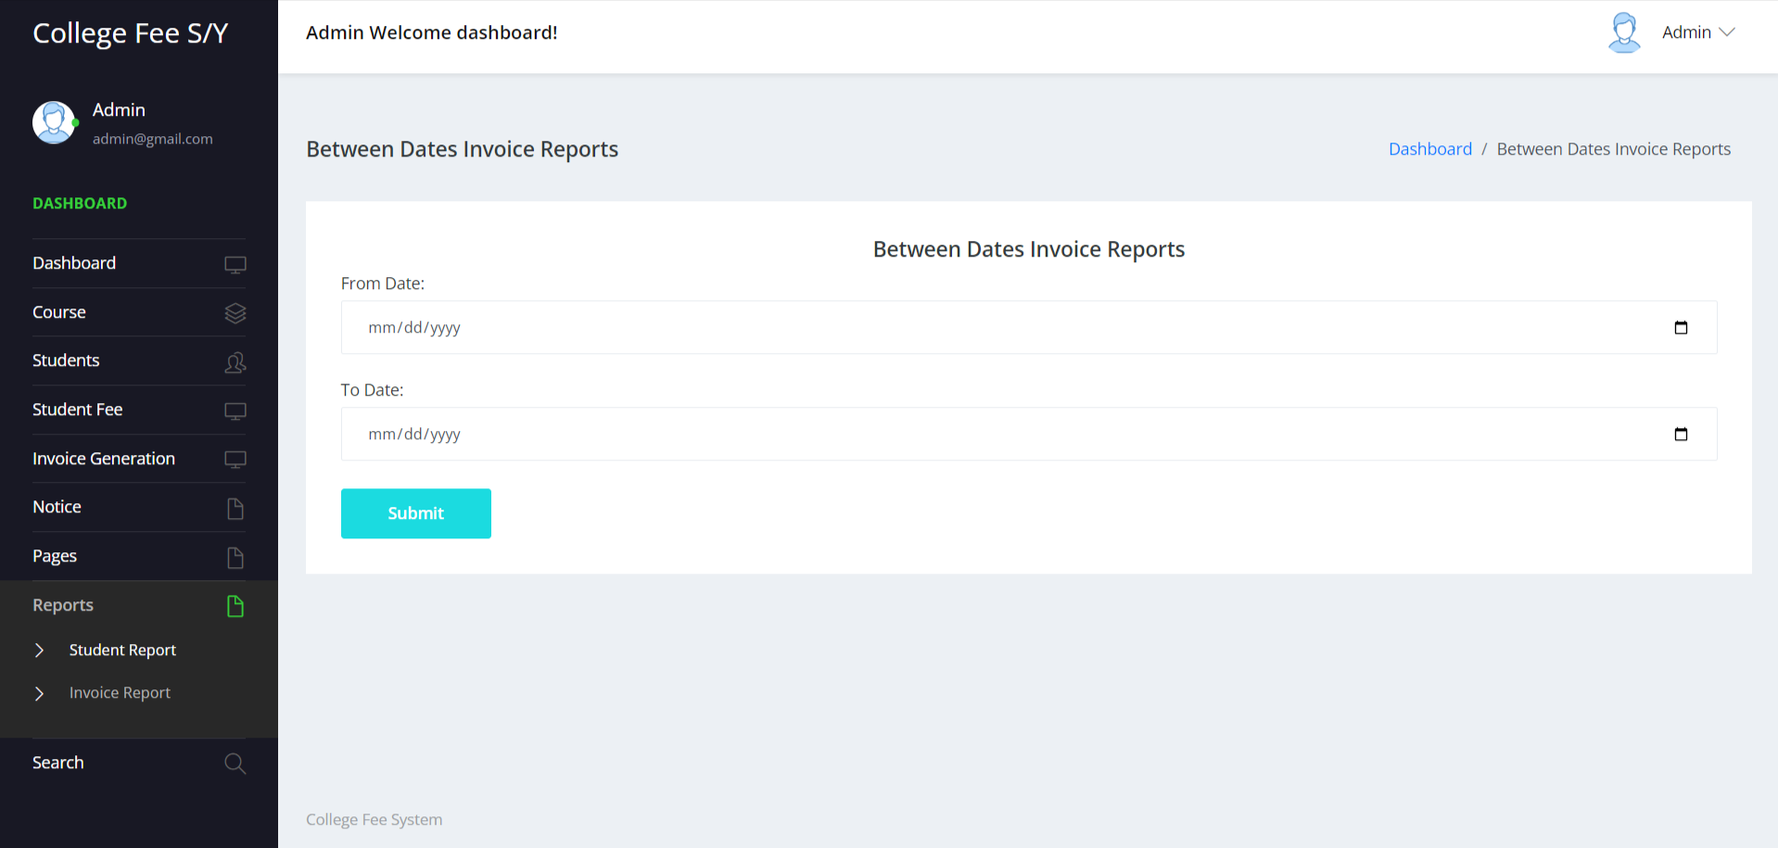

**View Details of Between Dates Invoice Report**

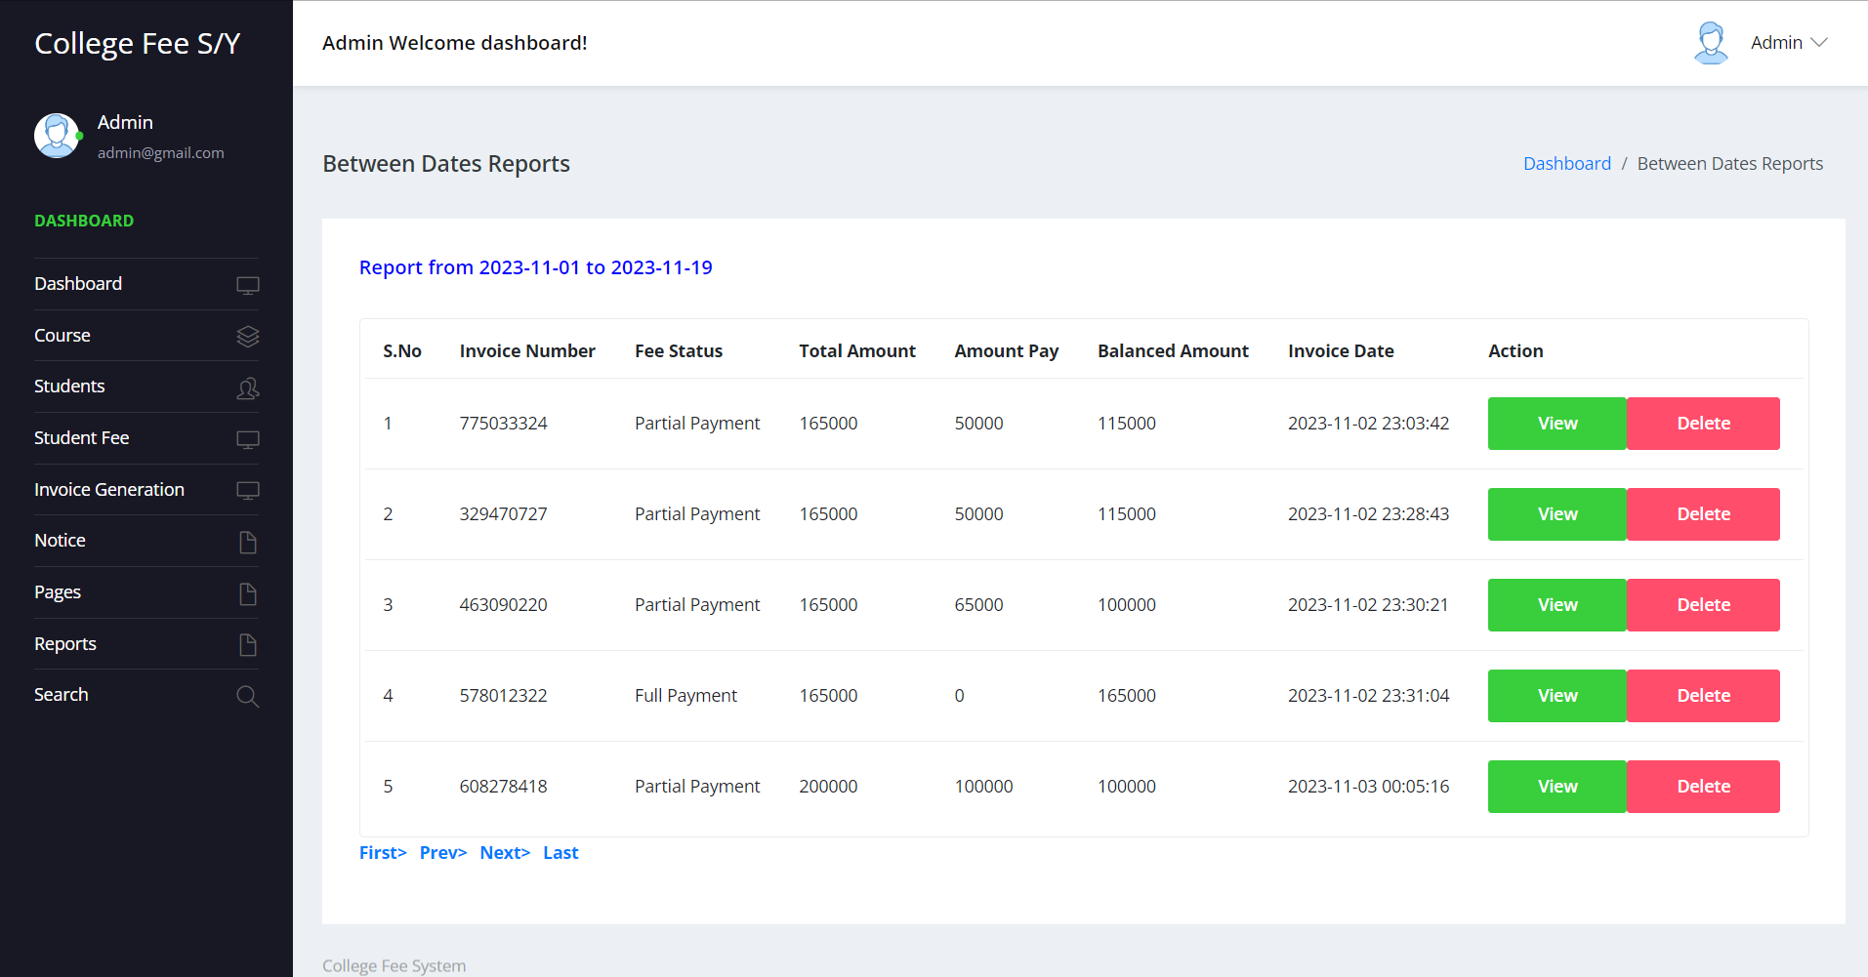

**Search Student**

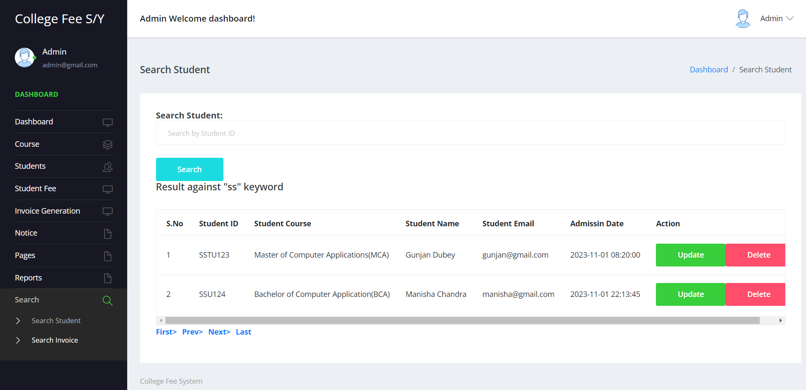

**Search Invoice**

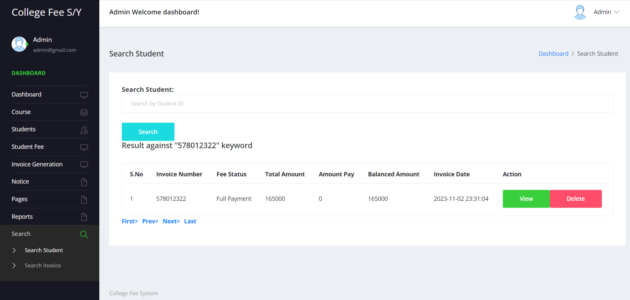

**Student Login**

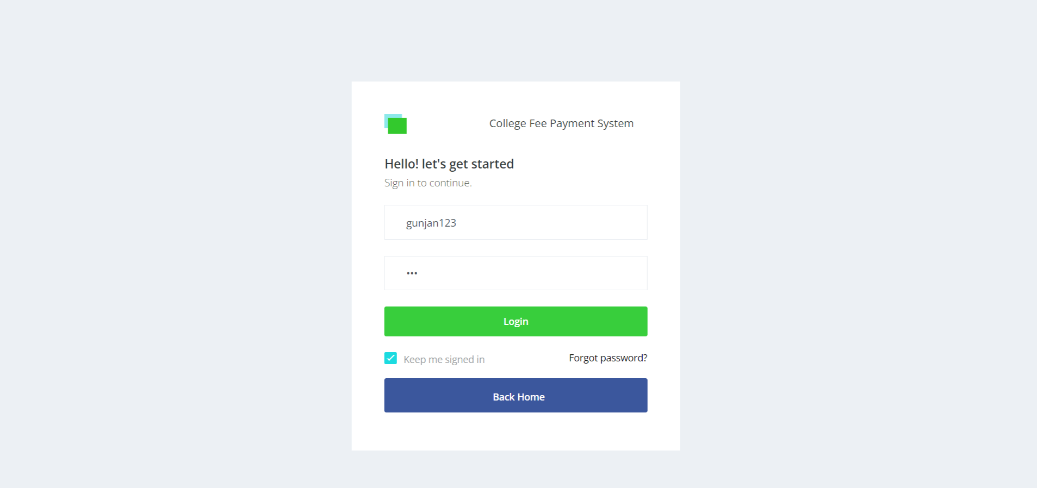

**Forgot Password**

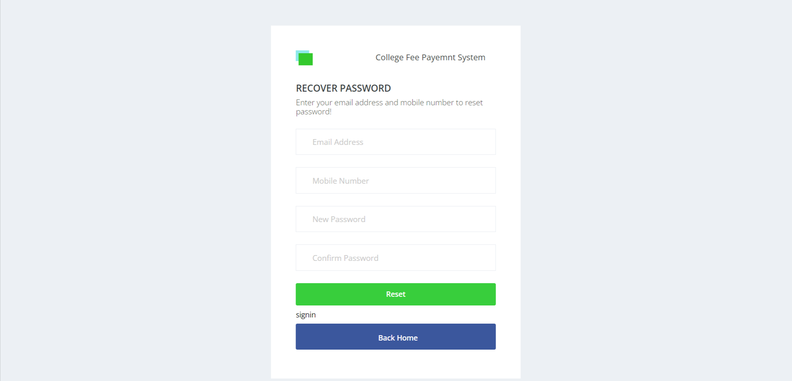

**Dashboard**

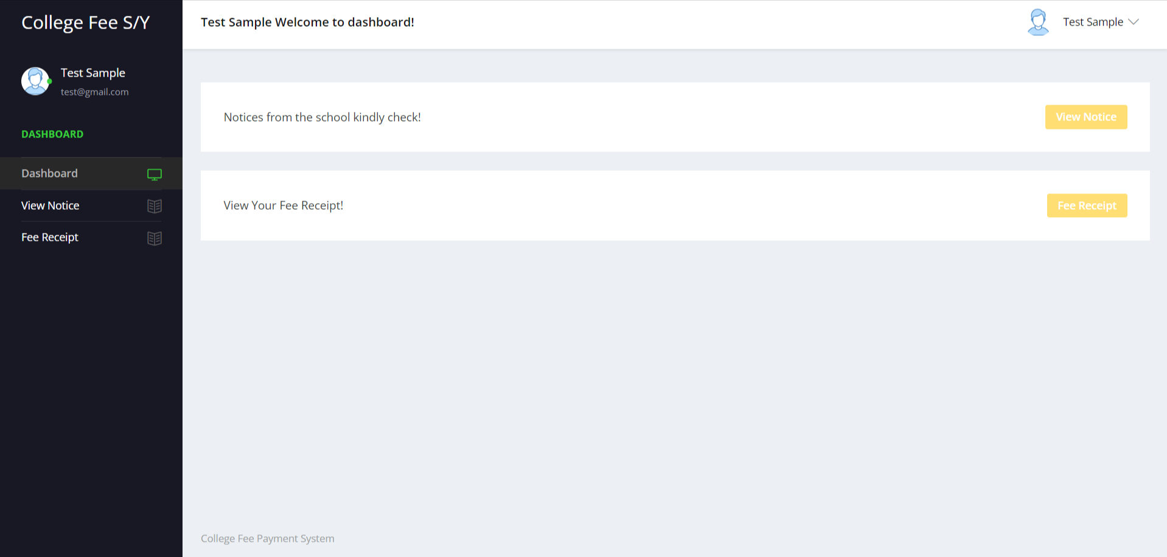

**Student Profile**

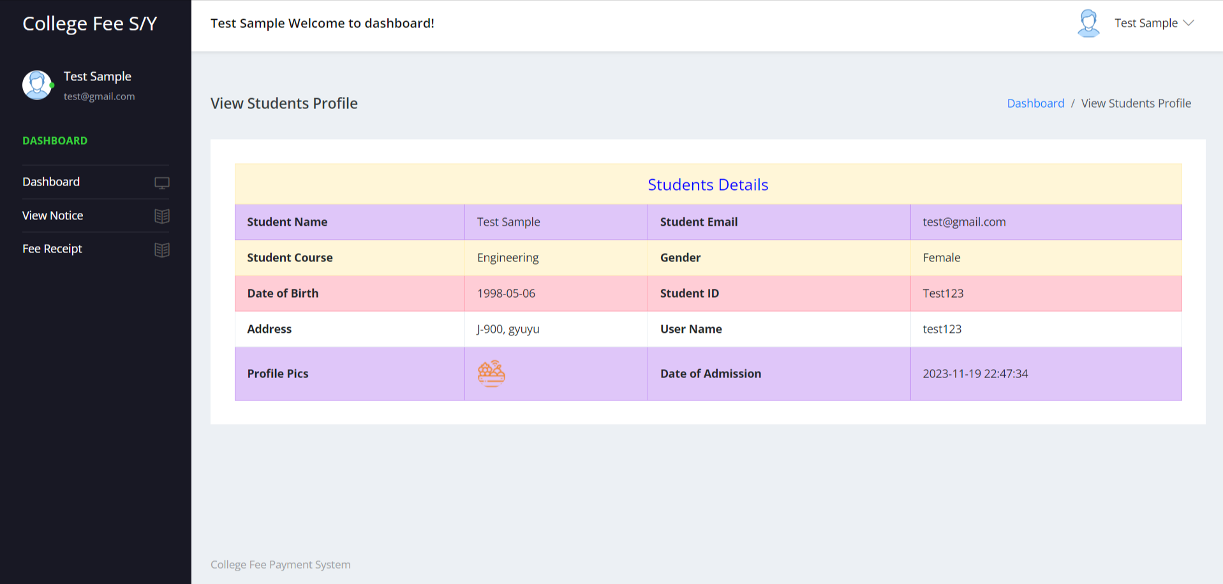

**Change Password**

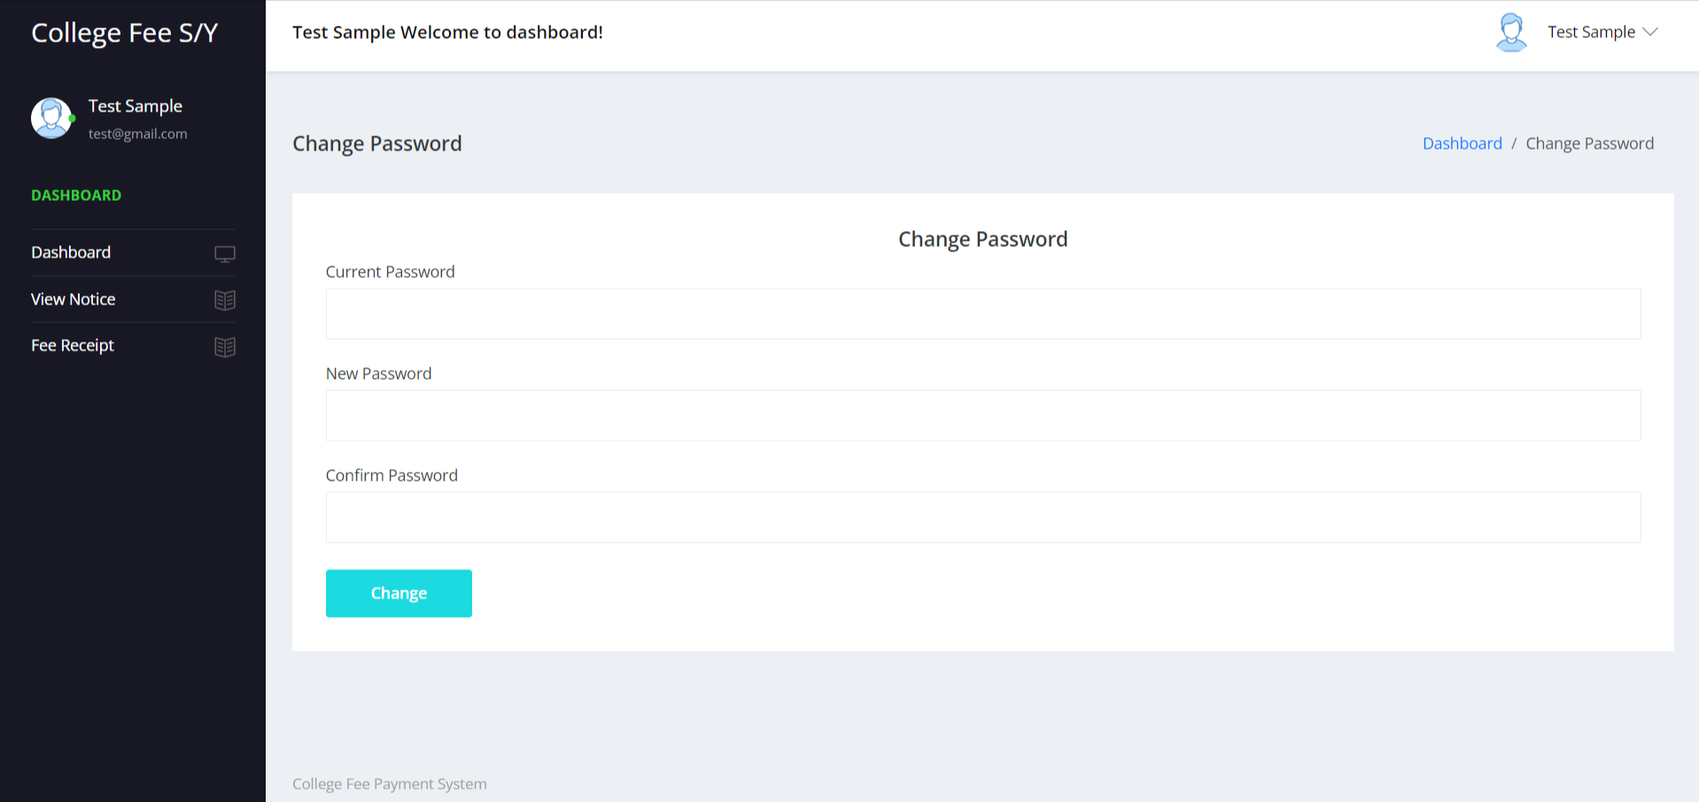

**View Notice**

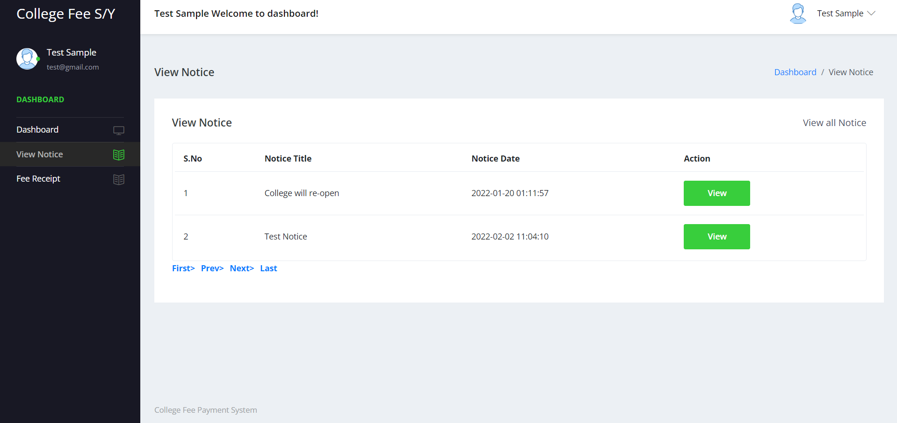

**Details of Notice**

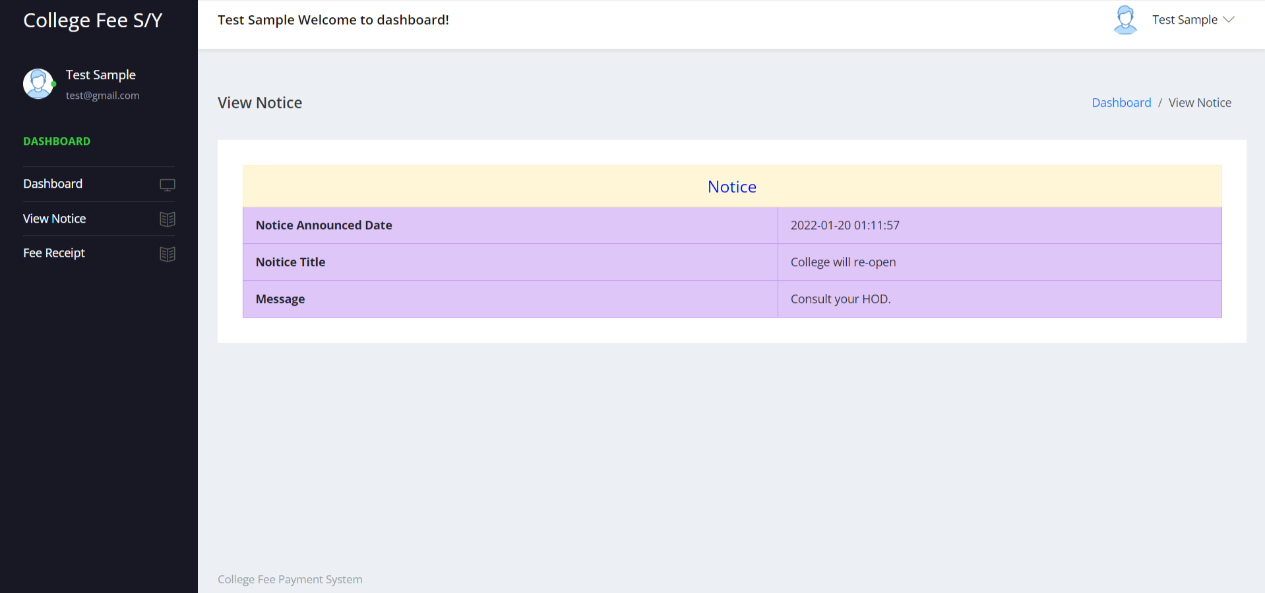

**Manage Invoice**

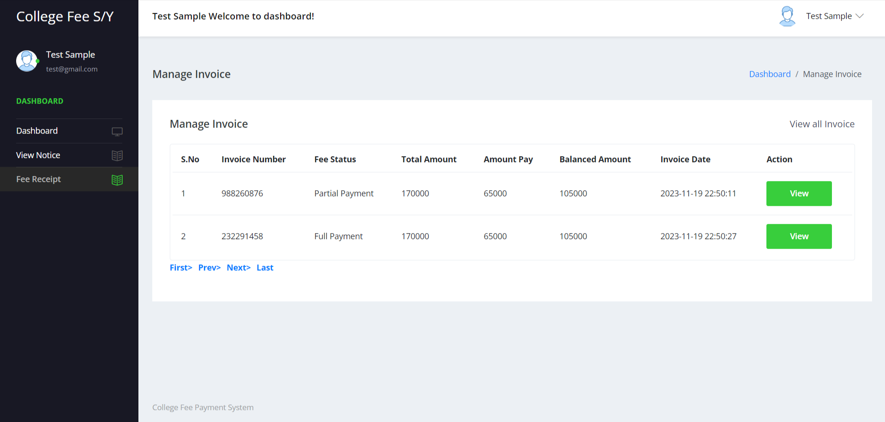

**View Invoice**

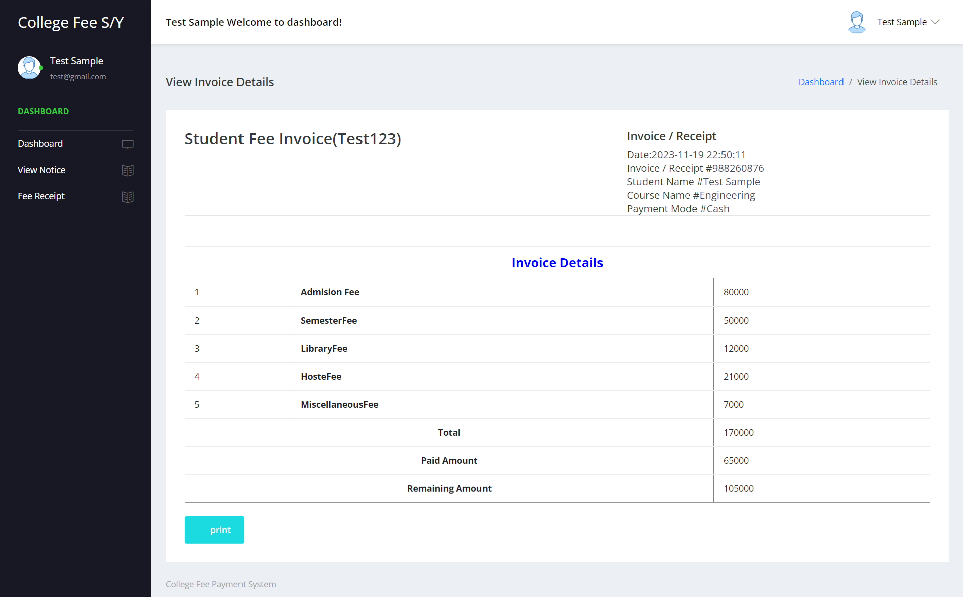

**Conclusion**

“College Fee Payment System “which is developed only for the stored the information about the students and fee receipt in computer which is very easy to handle if the any person which is knows the English language perfectly who have no knowledge about any software that person can handle this system. Also can update, delete students and fee receipt.

The Application was designed in such a way that future changes can be done easily. The following conclusions can be deduced from the development of the project.

* Automation of the entire system improves the productivity.
* It provides a friendly graphical user interface which proves to be better when compared to the existing system.
* It gives appropriate access to the authorized users depending on their permissions.
* It effectively overcomes the delay in communications.
* Updating of information becomes so easier.
* System security, data security and reliability are the striking features.
* The System has adequate scope for modification in future if it is necessary.

**References**

**For PHP**

* <https://www.w3schools.com/php/default.asp>
* <https://www.sitepoint.com/php/>
* <https://www.php.net/>

**For MySQL**

* <https://www.mysql.com/>
* [http://www.mysqltutorial.org](http://www.mysqltutorial.org/)

**For XAMPP**

* <https://www.apachefriends.org/download.html>